RPMS EHR Note Templates for documenting Virtual Check-in, Telemedicine and Telebehavioral Encounter Requirements during COVID-19 public health emergency:

There are many considerations for documentation requirements that are evolving during this COVID 19 public health emergency. Please follow CMS, State, and local guidance for specifics.
2 note template segments delivered:
- Virtual Check-in/Telemedicine_SEGMENT_v2.txml
- Virtual Check-in/Telebehavioral_SEGMEN_v2T.txml
Suggested use cases for incorporating note template segment:
- Add note template segment only to EHR quick note button configuration
  - Provider can then use their desired template
- Add note template segment to each identified provider’s individual template
- Make note template segment available in Shared Templates folder to pull into note as needed
Steps for incorporating note template segment:
- Import in note templates
- Informaticists will need to edit the TIU Template Field called: {FLD:OCA TM LOC PRV} to add their facility information.
- Identify template to add segment to:
  - Export out existing template (will need to save as is for future use)
  - Import template in and append name to differ from original template
  - Add to template:
    - Time based codes: include start time and stop time
    - Virtual Check-in (telephone): time spent in medical discussion with the patient (minutes): ____
  - Make other identified edits to accommodate documentation for these types of visits:
    - If 2 patient identifiers are in the template, should be removed from the segment being added
    - Other examples: remove vitals, edit physical exam
    - Do NOT include messages about billable encounters or data charges within legal health record; may consider adding a statement into newsletters, flyers, audio-visual invitation information, etc.
- Optional use of activity time for providers (required for behavioral health and public health nurses):
  - Add time to activity time to become part of visit file
  - Consider adding this first and pulling information into note with data object
- Carefully review template in conjunction with Health Information Management (HIM), clinicians, and billing team members for other needed changes
  - Edit top statement to reflect the relevant policy
  - Edit template field called {FLD:OCA VCI TM V2} to reflect modalities available
- Inform and train providers
Screenshots:
Virtual Check-in/Telemedicine_SEGMENT_v2.txml
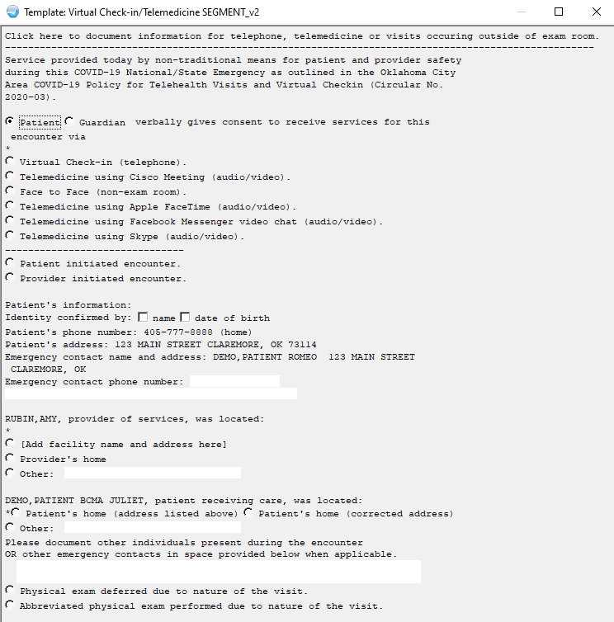

Virtual Check-in/Telebehavioral Health SEGMENT_v2.txml
