Telehealth Resources from IHS
Telebehavioral Health Center of Excellence (TBHCE) home page: https://www.ihs.gov/telebehavioral/
Tele-education homepage: https://www.ihs.gov/teleeducation/
The mission of the IHS TeleBehavioral Health Center of Excellence (TBHCE) tele-education program is to Equip, Connect, and Encourage healthcare providers working in the IHS, Tribal, and Urban Indian Health system and those serving American Indian/Alaska Native people and communities. More specifically, TBHCE aims to:
- Equip healthcare providers with the culturally sensitive education and training they need to provide excellent patient care,
- Connect healthcare providers by providing a space to learn from one another, and share best practices and solutions to challenges, and;
- Encourage healthcare providers by celebrating and sharing successes.
TBHCE COVID-19 specific recorded webinars: https://www.ihs.gov/teleeducation/c19webinars/

RPMS Training Website – Course Materials – COVID and Telehealth related
https://www.ihs.gov/rpms/training/course-materials/?parent=&fld=HIM+COVID-19+Impact+on+Telehealth+and+RPMS (this should link to a page like the screen shot below)
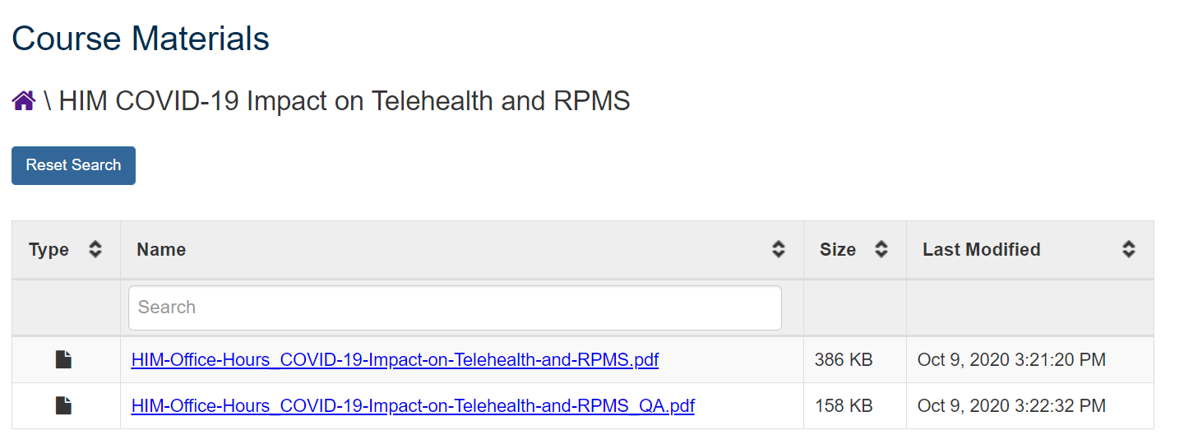

Other recorded trainings:
https://ihscqpub.cosocloud.com/content/connect/c1/7/en/events/event/shared/1812032102/event_landing.html?sco-id=1812096787&_charset_=utf-8
You will need to create an account to access these, but you may do so with any email address – it does NOT requite and ihs.gov email or D1 access.
