Guidelines for Screening, Management and pre-treatment work-up for Hepatitis C virus (hCv) Within

IHS, Tribal and urban Indian Healthcare Facilities
This template is a sample policy for HCV screening, follow up, and treatment. This is a template, and as such it is not comprehensive and does not mandate any clinical activities. It does provide a sample policy for I/T/U facilities to provide a range of HCV services at the primary care level, and should be adapted as needed to reflect local conditions and priorities. An HCV policy can be instrumental for clinical staff to understand HCV patient needs, clinical algorithms, and best practices. American Indians/Alaska Natives have the highest rate of mortality from HCV all I/T/U facilities are encouraged to provide early detection and linkage to care. For further questions or support, contact Dr. Jonathan Iralu, Chief Clinical Consultant, Infectious Disease, jonathan.iralu@ihs.gov

Purpose
To expand screening, management and pre-treatment care for HCV infection.

background
In the United States, an estimated 3 million persons are chronically infected with HCV. [1] Compared to other racial and ethnic groups, AI/ANs experience a higher rate of acute HCV incidence and one that has increased more quickly. [2] Compared to whites, AI/ANs experience a three-fold higher death rate from chronic liver disease—one of the multiple complications of chronic HCV infection. [3]
Certain practices pertaining to the screening, treatment, and management of HCV can prolong the length and quality of life of chronically infected patients. The American Association for the Study of Liver Diseases, the U.S. Preventive Services Task Force, and the Centers for Disease Control and Prevention endorse the below practices, as will IHS henceforth.
Among those with HCV in the U.S., 50% do not realize they are infected.[4] To identify HCV-infected patients, IHS clinicians should screen high-risk patients and all patients born from 1945 to 1965 for the presence of HCV antibodies. Patients born 1945-1965 accounts for the majority of HCV infections due to various causes including medical exposures or having injected drugs during in the 1950s-1980s.[5] Clinicians should confirm patients testing positive for HCV antibodies for HCV infection. After confirming HCV infection, clinicians should continue with a a pre-treatment checklist and in consultation with a specialist when needed, start patients on appropriate treatment regimens and continuously monitor patients’ progress until they reach a cure.
A number of individuals in the IHS patient population have been diagnosed with HCV, but have never been linked to treatment. Over a 30-year period, an estimated 85% of patients with acute HCV infection will go on to develop chronic HCV infection, 34% of patients will go on to develop cirrhosis, and 9% of patients will go on to develop hepatocellular carcinoma. Currently, effective treatments for HCV can reduce HCV viral loads to virtually non-detectable levels without the need for pegylated interferon, a medication associated with a longer duration of treatment and more severe side effects than other treatments. To prevent progression to cirrhosis, hepatocellular carcinoma, and liver failure, clinicians should stage HCV-infected patients, prioritizing patients with advanced liver fibrosis stages to receive immediate treatment. Clinicians should monitor patients with early liver fibrosis stages and also start these patients on treatment as it becomes available.

Definitions
Hepatitis C Virus (HCV): International Classification of Disease (ICD)-9: 070.41, 070.44, 070.51, 070.54, 070.70 through 070.71; ICD-10: B17.10, B17.11, B18.2, B19.20, B19.21 and HCV screening as Correct Procedural Terminology (CPT) 86803, or as per local Logical Observation Identifiers Names and Codes (LOINC) or laboratory taxonomies for hepatitis antibody testing.
Sustained Virologic Response (SVR): Hepatitis C virus remains undetectable in blood following completion of treatment. SVR is the goal of HCV treatment. SVR, the surrogate marker for HCV cure after completion of therapy is defined as undetectable HCV RNA using a highly sensitive assay 12 weeks following the end of treatment.
High-Risk Patient: A patient not currently diagnosed with HCV, but who has participated in certain behaviors, possesses certain medical conditions, and/or falls into certain categories that increase his or her risk of HCV infection. [6] The following patients should be routinely screened for HCV infection:
- Vietnam Veterans serving between 1964 and 1975
- HIV-positive individuals
- Patients who have ever injected illicit drugs, including those who injected drugs just once or a few times many years ago
- Patients with certain medical conditions, such as those with hemophilia with receipt of clotting factor concentrates before 1987, those with a current or history of long-term hemodialysis, and those with persistently abnormal alanine aminotransferase levels
- Patients who received a transfusion or organ transplant before July 1992 or received blood from a donor who later tested HCV-positive
- Patients with recognized exposure, for example, health care workers exposed after needle sticks, sharps or mucosal exposures to HCV-positive blood, and children born to HCV-positive mothers at 18 months of age or older

Resources
National guidelines support the following recommendations. Each recommendation is referenced to an online resource.

HCV SCREENING

Screen for HCV-infected patients
- Clinicians should screen the following categories of patients for HCV antibodies:
  - Patients born from 1945 to 1965 (one-time screening), which national data has shown constitutes 75% of reported cases [5]. Additional age ranges may be included in this screening where local data suggests an elevated HCV burden may exist.
  - Patients determined as high-risk (routine screening unless otherwise noted):
    - Vietnam Veterans serving between 1964 and 1975
    - HIV-positive individuals (at least annual screening for HIV-positive men who have sex with men)
    - Patients who have ever injected illicit drugs, including those who injected drugs just once or a few times many years ago (at least annual screening for current injection drug users)
    - Patients with certain medical conditions, such as those with hemophilia with receipt of clotting factor concentrates before 1987, those with a current or history of long-term hemodialysis, and those with persistently abnormal alanine aminotransferase levels
    - Patients who received a transfusion or organ transplant before July 1992 or received blood from a donor who later tested HCV-positive
    - Patients with recognized exposure, for example, health care workers exposed after needle sticks, sharps or mucosal exposures to HCV-positive blood, and children born to HCV-positive mothers

Test for HCV antibodies
- Clinicians should screen for HCV in patients identified as belonging to the above categories using immunoassays, such as the OraQuick HCV Rapid Antibody Test (OraSure Technologies) or an FDA-approved, laboratory-conducted HCV antibody assay [7]. The best assay for this purpose is a HCV antibody test with reflex ribonucleic (RNA) confirmation.

Test for HCV RNA and determine viral load
- Clinicians should perform Nucleic Acid Testing (NAT) for patients with reactive immunoassays (and for patients with non-reactive immunoassays if patients are immunocompromised or have been recently exposed to HCV).
- Clinicians should consider a reactive immunoassay and a negative NAT result to signify a false positive serology or the patient having cleared infection. Clinicians should link patients with a positive NAT result to care; Clinicians should not repeat NAT for patients with a negative NAT result unless patients have been exposed to HCV within the past 6 months, patients present with clinical evidence of disease, or specimens have been mishandled or improperly stored.
- Clinicians should determine a quantitative HCV RNA viral load to provide baseline markers to determine treatment progress.
- Patients who are positive for HCV+ Ab but HCV RNA negative may have spontaneously cleared the virus. This occurs in an estimated 15%-25% of HCV exposed individuals. Such patients need no further follow up for HCV (except counseling on risk behaviors as appropriate) and will test positive for HCV Ab+ during their lifetimes. Consequently, any subsequent testing for HCV in this population subset should immediately include RNA testing.

Perform laboratory evaluation
Upon confirming chronic HCV infection, clinicians should perform the following set of additional laboratory tests (where tests are available):
- General laboratory evaluation, including complete blood count, platelet count, thyroid function tests, and renal function tests
- Tests to determine hepatic inflammation, such as alanine aminotransferase or aspartate aminotransferase
- Tests to determine hepatobiliary disease, such as bilirubin and alkaline phosphatase
- Tests to determine hepatic function, such as serum albumin and prothrombin time
- Assays to detect significant co-infections, such as hepatitis A antibody, hepatitis B surface antigen, hepatitis B surface antibody, hepatitis B core antibody, HIV antibody

Perform complete patient history and examination
Upon confirming chronic HCV infection, clinicians should perform complete patient medical histories and physical examinations. Clinicians should determine patients’ risk factors for acquiring HCV infection, psychiatric history, significant comorbidities, co-infection with other viruses, stigmata of chronic liver disease, clinical manifestations attributable to HCV infection, history of prior treatment, and previous assessment of liver fibrosis. [8] Upon performing complete patient medical histories and physical examinations, clinicians should treat conditions that may delay HCV treatment and/or prevent patients from obtaining sustained virologic response.
Clinicians should also assess patients’ alcohol histories to determine dependence that may delay treatment and/or prevent patients from achieving a sustained virologic response.

Psychiatric history
Whereas HCV treatments including interferon (a medication associated with neuropsychiatric side effects) are no longer necessary to develop a sustained virologic response, clinicians should still assess patients’ past or current psychiatric issues during the initial visit. Psychiatric issues are generally not contraindications for HCV treatment. Upon diagnosing psychiatric issues, clinicians should link patients to psychiatric treatment, as appropriate.

Significant comorbidities
Clinicians should determine secondary causes of liver disease, such as non-alcoholic fatty liver disease, alcoholic hepatitis, or autoimmune hepatitis. Clinicians should also advise obese patients to lose weight prior to beginning HCV treatment, and cessation of alcohol and tobacco use.

Co-infection with other viruses
Clinicians should screen HCV-infected patients for hepatitis A virus, hepatitis B virus, and human immunodeficiency virus (HIV). If patient is not immune to hepatitis A or B, consider vaccination.

Stigmata of chronic liver disease
Clinicians may consider the presence of the following physical signs and symptoms (in decreasing order of the likelihood ratio of cirrhosis) as indicators of cirrhosis: caput medusae/dilated abdominal wall vessels, loss of body/pubic hair, hepatic encephalopathy, gynecomastia, ascites, spider angiomata, palmar erythema, jaundice and scleral icterus, and liver stiffness.

Clinical manifestations
Clinicians should determine extrahepatic clinical manifestations of chronic HCV infection, such as arthralgias, neuropathy, nephropathy, glomerulonephritis, livedo reticularis, lichen planus, and cold agglutinin disease.

History of prior treatment
Clinicians should determine if patients have previously undergone HCV treatment. If patients have failed to obtain sustained virologic response with previous HCV treatment, clinicians should determine the following with regard to previous HCV treatment: medications, duration, timing, patient’s degree of adherence, adverse effects, and when possible, viral kinetics and outcome.

Previous assessment of liver fibrosis
Clinicians should determine whether patients have previously had a liver biopsy. For patients who have had a liver biopsy, clinicians should record the date of the biopsy, the sample size, the fibrosis scoring system, and the fibrosis score. Clinicians should also note any previously performed non-invasive tests for determining liver fibrosis scores.

Stage HCV Liver Fibrosis
Although the gold standard to stage hepatic fibrosis is by performing a liver biopsy with histologic analysis, noninvasive testing with ultrasound transient elastography (FibroScan_{TM}) or blood test staging methods are widely used, acceptable, and more feasible. These methods include two of the following non-invasive tests for indirect markers of cirrhosis: Aspartate Aminotransferase-to-Platelet Ratio Index (APRI), Fibrosis-4 (FIB-4), and FibroSure.
When using non-invasive tests, if both tests determine the fibrosis score as F1, treatment is optional if patients have no contraindications; if both tests determine the fibrosis score as F2 or above, clinicians should begin patients on antiviral therapy if patient has no contraindications. If tests determine disparate results, clinicians should consider following up with a liver biopsy or FibroScan. [9]

Preventive care and counseling for chronic HCV patients
Before patients begin treatment, have a confirmed positive HCV RNA level, preferably quantitative in nature. A genotype test will also be needed to determine the recommended course of treatment. Clinicians should prioritize patients with advanced or compensated cirrhosis (F3 and F4 fibrosis scores, respectively), patients with severe or extrahepatic HCV, and liver transplant recipients to receive immediate treatment. [10-13]
Patients should also be vaccinated for Hepatitis A and B, if immunity is not detected.
While treatment may depend on a variety of factors, linkage to care for patients with chronic HCV infection should be as timely as possible. IHS sites should determine what is the best course of action for linkage to care that are the most feasible for their patients, based on the overall case load and acuity. Linkage to care can entail multiple options such as external referrals to specialists, or treatment within the facility with on-site (visiting specialist clinic) or remote specialist support (e.g. telehealth) for primary care clinician-led HCV treatment programs.
All HCV-confirmed patients should be counseled in regards to reducing the risk for spread of HCV infection, the risks for sexual partners, and the avoidance of hepatotoxic substances (OTC and prescription drugs, alcohol, and supplement use).
When appropriate, clinicians should counsel patients on weight loss and diet. Clinicians should advise patients about all restrictions and/or considerations before patients begin treatment. A pre-treatment checklist is in the appendix of this policy.
Approach to Monitoring After Receiving HCV Therapy:
The approach to monitoring patients following completion of a course of HCV therapy depends entirely on the patient's response to therapy. Three main scenarios exist: (a) the patient achieved an SVR, (b) the patient completed therapy but did not achieve an SVR, or (c) the patient had an inadequate treatment course because of adherence problems, intolerance, or laboratory toxicity necessitating premature discontinuation of the treatment regimen.
Monitoring Patients who Achieved an SVR: Patients who have an undetectable HCV RNA at week 12 (or later) after completing HCV therapy are considered to have achieved an SVR. In a review by Welker of 44 studies involving more than 4,228 patients who achieved an SVR with an interferon-based regimen, 97% of patients maintained the SVR during the long-term follow-up period. Some experts will obtain an HCV RNA level 24 weeks after completing treatment in selected patients. In a more recent review by Manns, more than 99.2% of 1002 patients who achieved an SVR12 with interferon- or peginterferon-based therapy maintained undetectable HCV RNA levels for 5 years. Comparable data on the long-term durability of treatment response with all-oral DAA therapy is not yet available, but it is generally thought that SVR12 responses will represent sustained HCV clearance similar to that seen with interferon-based therapy. All patients who achieve an SVR should clearly understand they are not immune to HCV and can become reinfected with HCV. The AASLD/IDSA Guidance stratifies the follow-up for persons who achieve an SVR based on the degree of hepatic fibrosis and the risk of developing reinfection.
- Patients with without advanced fibrosis (Metavir stage F0-F2): These patients do not need special monitoring or follow-up specifically for HCV or liver care. This recommendation is based on data that show patients with SVR following HCV treatment generally do not have further progression of HCV-related liver fibrosis.
- Patients with Advanced Fibrosis (Metavir stage F3-F4): Although fibrosis may improve in these patients, they are considered to have persistent risk, albeit lower than before achieving an SVR, for developing hepatocellular carcinoma. Accordingly, these patients should have surveillance for hepatocellular carcinoma (HCC) with hepatic ultrasound every 6 months. In addition, patients with cirrhosis (F4 fibrosis) should have a baseline upper endoscopy to screen for varices, unless this has previously been done. Patients identified with varices should receive appropriate management and follow-up.
- Patients with Ongoing Risk of HCV Reinfection: Regardless of the degree of hepatic fibrosis, all patients with ongoing risk for acquiring HCV should have periodic assessment for HCV reinfection and counseling on prevention of reinfection. Obtaining HCV antibody does not provide useful information in these individuals with known prior HCV infection since they are highly likely to remain antibody positive. Thus, reassessment should consist of a quantitative HCV RNA level. In addition, for these patients, any flare in liver enzyme tests should prompt evaluation for reinfection with a quantitative HCV RNA level.
- Patients with Persistently Abnormal Liver Tests: Any patient that develops persistently elevated liver tests should undergo evaluation for possible other causes of liver disease, such as alcohol use, iron overload, or fatty liver disease.
Monitoring for Patients who do not Achieve SVR: The AASLD/IDSA guidance recommends the following for patients who did not achieve an SVR with HCV therapy.
- All Patients: For all patients who did not achieve an SVR, follow-up laboratory testing should occur every 6 to 12 months with a hepatic function panel, complete blood count, and international normalized ratio. In addition, these patients should have periodic reevaluation for retreatment, especially as new options become available. It is important these patients receive counseling for alcohol abstinence (or safe use) and avoidance of hepatotoxic medications.
- Patients with Advanced Fibrosis (Metavir Stage F3-F4): These patients should have surveillance for hepatocellular carcinoma with hepatic ultrasound every 6 months. In addition, patients with cirrhosis (F4 fibrosis) should have a baseline upper endoscopy to screen for varices, unless this has previously been done. Patients identified with varices should receive appropriate management and follow-up.

Reporting
- Health providers in are required to report cases of chlamydia, gonorrhea, syphilis, genital herpes and chancroid to the local health department.
- STI reporting forms are available at: .

Questions and Resources
- This sample policy can be adapted for local use. These documents and accompanying information sheets can be found on the IHS HCV Program website: https://www.ihs.gov/Epi/index.cfm?module=epi_hepatitis_resources.
- Questions regarding HCV diagnosis, treatment, patient and partner follow-up, and reporting should be directed to the appropriate local tribal health department or to the respective state HCV program.
- HCV educational resources for providers and tribal health departments are available from the CDC [http://www.cdc.gov/hepatitis/hcv/patienteduhcv.htm] and the Northwest Portland Area Indian Health Board [http://www.npaihb.org/epicenter/project/prt_reports_publications_media_campaigns#HEP-C Brochure and Radio PSAs].

Contact Information for Local Health Department
<<insert address for reporting>>
<<insert phone number>>
<<insert fax number>>

Appendix
(i) Recommendations for the Identification of Chronic Hepatitis C Virus Infection Among Persons Born During 1945-1965. MMWR 2012; Vol. 61 (RR-4)
(ii) Recommendations for Prevention and Control of Hepatitis C Virus (HCV) Infection and HCV-Related Chronic Disease. MMWR 1998; Vol. 47 (RR-19)

(iii) Recommended Testing Sequence for Identifying Current Hepatitis C Virus (HCV) Infection http://www.cdc.gov/hepatitis/HCV/PDFs/hcv_flow.pdf
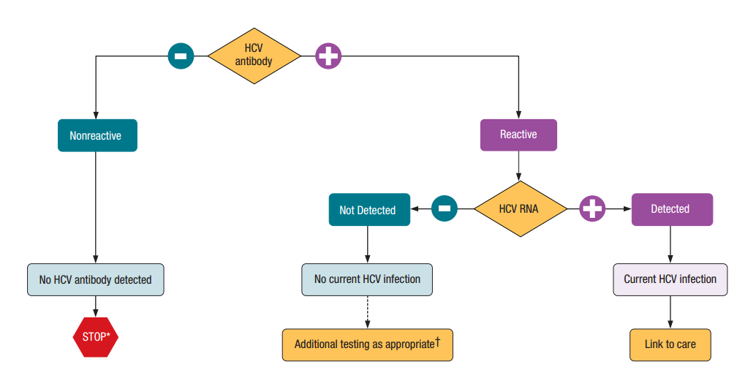
*For persons who might have been exposed to HCV within the past 6 months, testing for HCV RNA or follow-up testing for HCV antibody is recommended. For persons who are immunocompromised, testing for HCV RNA can be considered.
† To differentiate past, resolved HCV infection from biologic false positivity for HCV antibody, testing with another HCV antibody assay can be considered. Repeat HCV RNA testing if the person tested is suspected to have had HCV exposure within the past 6 months or has clinical evidence of HCV disease, or if there is concern regarding the handling or storage of the test specimen.

Source: CDC. Testing for HCV infection: An update of guidance for clinicians and laboratorians. MMWR 2013;62(18).

(iv) Screening for Hepatitis C Virus Infection in Adults, American Association for the Study of Liver Disease http://www.hcvguidelines.org/

(v) Natural History of Hepatitis C Viral Infection [13]
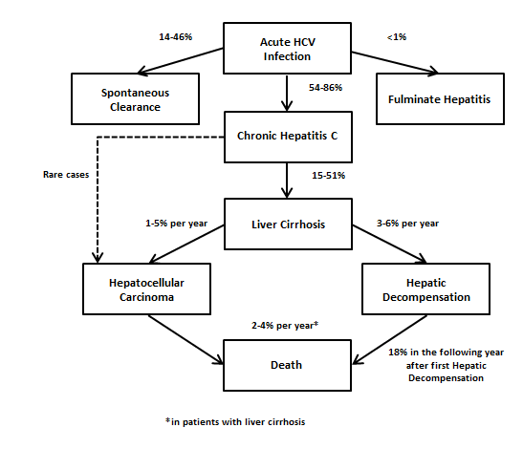

(vi) Evaluation of Fibrosis in Patients with Chronic HCV [9]
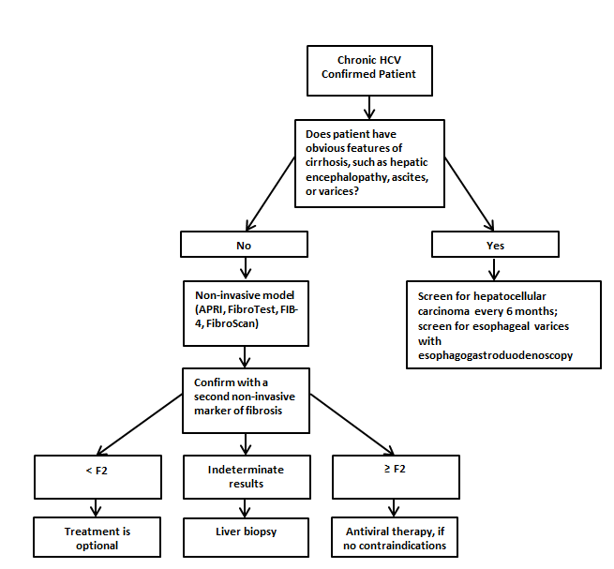

(vii) When and in Whom to Initiate HCV Therapy: Factors Associated with Accelerated Fibrosis Progression [10]
Host | Viral
Non-Modifiable | Genotype 3
Fibrosis stage | Co-infection with hepatitis B virus (HBV)
Inflammation grade | Co-infection with human immunodeficiency virus (HIV)
Older age at time of infection
Male sex
Organ transplant
Modifiable
Alcohol consumption
Obesity
Nonalcoholic fatty liver disease
Insulin resistance

(viii) Hepatitis C Pre-Treatment Checklist:
• Labs:
Immediately prior: □ Pregnancy test □ Uric Acid (with ribavirin)
Within 1 month: □ Complete Blood Count with differential
□ Comprehensive Metabolic Panel (If GFR <30, do not start treatment; consult Liver Disease Specialist)
□ PT/INR □ HCV RNA
Within 3 months: □ Genotype confirmation
Within 6 months: □ AFP □ TSH □ A1C or Fasting Glucose
□ Vitamin D 25OH
Within 1 year: □ HIV screening
• Screen & Review: AUDIT-C __PHQ-9 ___Drug & Alcohol Screen (at discretion of provider)
• Vaccine Status/Screening: Hepatitis A & B vaccinations are recommended for all persons with HCV
□ Hepatitis A (If vaccine status is unknown, check hep A total IgG)
□ Hepatitis B (If vaccine status is unknown, check HBsAg & HBsAb) Other vaccines as appropriate:
□ Flu (annually) □ Pneumococcal-13 (≥ age 65 or high risk/immunosuppressed)
□ Pneumococcal-23 (≥ age 50 AN/AI living in Alaska or high risk)
□ Td (once every 10 years) OR Tdap (once) □ Zoster (≥ age 60) Pre-Treatment Clinical Evaluation:
□ Medical history including liver disease history and past hepatitis C treatment
□ Hypertension/Diabetes controlled □ Counsel about smoking cessation
□ Counsel about pregnancy prevention (see Treatment Agreement)
□ Review all medications; check for drug interactions with treatment meds
□ Physical Exam □ Hepatitis C Treatment Agreement reviewed and signed
□ ECG (If treatment includes ribavirin or peginterferon, over age 65 or h/o cardiac disease)
If treatment includes peginterferon complete the following:
□ Mental Health Evaluation if h/o depression or other psychiatric condition
□ Stress Test (h/o cardiac disease, prior to peginterferon or ribavirin)
□ Dilated retinal/ophthalmology exam (peginterferon candidates only who have HTN, HLD,
DM, or h/o retinal disease or blindness)

References
1. Denniston, M.M., et al., Chronic hepatitis C virus infection in the United States, National Health and Nutrition Examination Survey 2003 to 2010. Ann Intern Med, 2014. 160(5): p. 293-300.
2. Prevention, C.f.D.C.a. Surveillance for Viral Hepatitis – United States, 2012. 2014 9/2/14 [cited 2014 10/27]; Available from: http://www.cdc.gov/hepatitis/Statistics/2012Surveillance/Commentary.htm#hepC.
3. Suryaprasad, A., et al., Mortality caused by chronic liver disease among American Indians and Alaska Natives in the United States, 1999-2009. Am J Public Health, 2014. 104 Suppl 3: p. S350-8.
4. Younossi, Z.M., et al., Knowledge about infection is the only predictor of treatment in patients with chronic hepatitis C. J Viral Hepat, 2013. 20(8): p. 550-5.
5. Smith, B.D., et al., Recommendations for the identification of chronic hepatitis C virus infection among persons born during 1945-1965. MMWR Recomm Rep, 2012. 61(RR-4): p. 1-32.
6. Testing Recommendations for Hepatitis C Virus Infection. June 25, 2014 [cited 2014 November 14]; Available from: http://www.cdc.gov/hepatitis/HCV/GuidelinesC.htm.
7. American Association for the Study of Liver Diseases, http://www.hcvguidelines.org/full-report/testing-and-linkage-care-table-1-fda-approved-commercially-available-anti-hcv-screening (accessed Aug 25, 2016).
8. Panneer, N., et al., HIV and hepatitis C virus infection in the United States: whom and how to test. Clin Infect Dis, 2014. 59(6): p. 875-82.
9. Ramers, C.D. Initial Evaluation of Persons with Chronic Hepatitis C. 2013 December 9, 2013 [cited 2014 November 19]; Available from: http://www.hepatitisc.uw.edu/go/evaluation-staging-monitoring/initial-evaluation-chronic/core-concept/all#screening-other-causes-contributors-liver-disease.
10. Bhogal, H. and R.K. Sterling, Staging of liver disease: which option is right for my patient? Infect Dis Clin North Am, 2012. 26(4): p. 849-61.
11. University of Washington, http://www.hepatitisc.uw.edu/page/clinical-calculators/apri (accessed Aug 25, 2016).
12. Lin ZH, Xin YN, Dong QJ, et al. Performance of the aspartate aminotransferase-to-platelet ratio index for the staging of hepatitis C-related fibrosis: an updated meta-analysis. Hepatology. 2011;53:726-36.
13. Chou R, Wasson N. Blood tests to diagnose fibrosis or cirrhosis in patients with chronic hepatitis C virus infection: a systematic review. Ann Intern Med. 2013;158:807-20.
14. When and in Whom to Initiate HCV Therapy. Recommendations for Testing, Managing, and Treating Hepatitis C 2014 November 20, 2014 [cited 2014 December 3]; Available from: http://www.hcvguidelines.org/full-report/when-and-whom-initiate-hcv-therapy.

