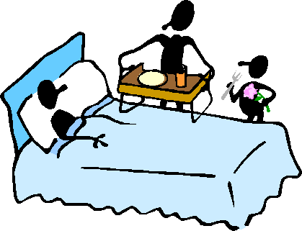***Sick Day Management***

***For patients with diabetes***

Symptoms of the common cold or flu can cause serious problems for patients with diabetes. Here are steps to manage short-term illnesses at home:

1. **Medications:** **Continue to take your insulin and/or diabetes pills unless you have the symptoms below.** Illnesses can raise blood sugar levels. People have had to go to the hospital because they stopped taking their insulin or medications when they were sick.
2. **Stop** the following medications while you are sick if you have:
   * Severe Nausea/Vomiting/Diarrhea:

***Metformin, Empagliflozin, Injectable Liraglutide, Injectable Exenatide***

* + Fever: ***Metformin, Empagliflozin***
  + Sick In Bed and Reduced Food Intake**: *Empagliflozin, (May need to adjust Glipizide and Insulin doses – call your health care provider)***

1. **Check blood glucose (sugar) levels** every **4** hours or when not feeling right.

Write results in blood sugar log.

**Usual Target Blood Glucose Goal while Sick: 110-180**

**Usual Target Blood Glucose Goal while Well:**  **80-130**

If: High Risk for low blood glucose: Goal - **Sick: 140-180**

High Risk for low blood glucose: Goal - **Well: 100-140**

IF UNABLE TO GET BLOOD GLUCOSE TO TARGET RANGES, **CALL** YOUR Healthy Heart Provider or Primary Care Provider Team for medication adjustments as soon as possible.

**Yakama Indian Health Service: 509-865-1709**

**Yakama IHS Healthy Heart Program: 509-865-1715**

**Treat Low Blood Glucose: B**elow **70** or if symptoms of low blood glucose by: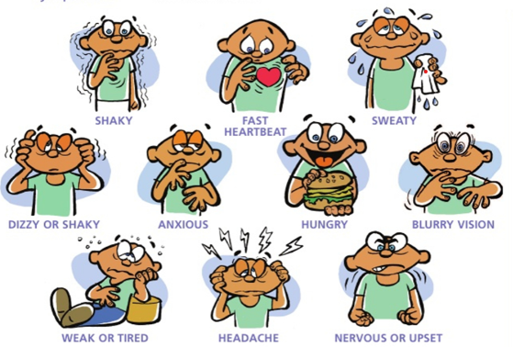 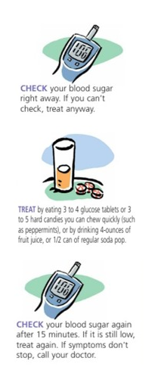

**CHECK** your blood glucose right away. If you can’t check, treat anyway.

**TREAT** with 15 grams carbohydrate

3- 4 Glucose tablets or hard candies,

4 oz. (1/2 cup) fruit juice or regular soda.

**CHECK** your blood glucose again after 15 minutes. If still low, treat again. Call your provider if symptoms don’t stop.

1. **Drink Fluids**: **8 ounces or 1 cup every hour while awake AND every 3rd hour drink 8 ounces of a sodium-rich choice such as bouillon/broth.**

Cold symptoms such as high fever, diarrhea, nausea, vomiting can cause you to lose too much body water. High blood sugar from the stress of being sick can cause dehydration too.

1. **Meal Planning**

* **If able to eat meals**, try to eat ***usual meals and drink*** ***8 ounces of calorie-free extra fluids*** each hour throughout the day. Examples: Water, Tea (unsweetened), Broth, Diet Soda, Sugar-Free Jell-O
* **If NOT able to eat usual meals,** try eating or drinking food or beverages with ***15 grams of carbohydrate every hour*** AND continue to ***drink extra calorie-free fluids*** in between.

Examples if not eating usual meals:

**Foods/Fluids that contain 15 grams of Carbohydrate: 1 serving each hour during the day**

* ½ cup apple juice ½ cup regular soft drink (caffeine free) 7-Up, Sprite
* [](http://images.google.com/imgres?imgurl=http://www.diabetes123.com/presentations/03-cwd-sick%2520days-net20031103_files/slide0387_image003.png&imgrefurl=http://www.diabetes123.com/presentations/03-cwd-sick%2520days-net20031103_files/slide0387.htm&h=256&w=281&sz=9&hl=en&start=74&tbnid=xBfaDjIpP5EQoM:&tbnh=104&tbnw=114&prev=/images%3Fq%3Dsick%2Bdays%26start%3D72%26ndsp%3D18%26svnum%3D10%26hl%3Den%26lr%3D%26sa%3DN)1 double stick popsicle 1 cup Gatorade or PowerAde
* ¼ cup regular pudding 1/3 cup frozen yogurt
* ½ cup regular ice cream ¼ cup sherbet
* 1 slice dry toast ½ cup cooked cereal
* 6 saltine crackers 1/3 cup low fat milk Milkshake
* 1 cup soup ½ cup regular gelatin/Jell-O

1. Keep a record of all food and drink you eat while you are ill. Report this to your health care provider.

[](http://images.google.com/imgres?imgurl=http://www.health.co.hays.tx.us/images/gif/womens_immunization.gif&imgrefurl=http://www.health.co.hays.tx.us/womens_health/womens_health_immunization.htm&h=200&w=163&sz=11&hl=en&start=99&tbnid=Yho7f0CIH3YFmM:&tbnh=104&tbnw=85&prev=/images%3Fq%3Dimmunization%26start%3D96%26ndsp%3D18%26svnum%3D10%26hl%3Den%26lr%3D%26safe%3Dstrict%26client%3Ddell-usuk-rel%26channel%3Dus%26sa%3DN%26ad%3Dw5)

1. If you are sick and your blood glucose is consistently very high (**above 250**) call your health care provider immediately. You may need medication for an infection, nausea, vomiting, diarrhea, etc.

[](http://images.google.com/imgres?imgurl=http://hieperventiel.web-log.nl/photos/uncategorized/dehydration.gif&imgrefurl=http://hieperventiel.web-log.nl/&h=567&w=752&sz=19&hl=en&start=77&tbnid=RcNp7P_RVhOG7M:&tbnh=106&tbnw=141&prev=/images%3Fq%3Ddehydration%26start%3D72%26ndsp%3D18%26svnum%3D10%26hl%3Den%26lr%3D%26safe%3Dstrict%26client%3Ddell-usuk-rel%26channel%3Dus%26sa%3DN%26ad%3Dw5)***Contact Health Care provider if:***

* Fever of 101° Fahrenheit or greater
* Have cold or flu symptoms for longer than 4 days with no improvement
* Have nausea, vomiting or diarrhea persist (especially with no food or fluid intake) for more than 4 hours.
* Symptoms of shakiness or nervous feeling, lightheadedness, sweating, rapid heart rate or confusion that do not improve after eating carbohydrate foods.
* Any of the following problems on the feet: burns, splinters, stubbed toe, foot trauma, blister, swelling, black and blue discoloration, bleeding or oozing of fluid.
* A persistent cough

**Yakama Indian Health Service: 509-865-1709**

**Yakama IHS Healthy Heart Program: 509-865-1715**

* Change in vision
* A sore or cut that does not heal
* Severe tooth pain

***Seek Urgent or Emergency Care if you have:***

* MC900411406[1]Chest pain or shortness of breath
* Trouble breathing, swelling of legs and/or hands, have gained more than 2 pounds overnight or more then 3-5 pounds in one week
* Numbness or tingling in arms or hands, trouble walking, stumbling
* Confusion or can’t think clearly