HIV

Hashtags: #AIDsAwareness #TakeControl #KnowYourStatus #GetTested #STDTesting #STITesting #SexualHealth #NativeHealth #IndigenousHealth #HIVTesting

Social Media Posts & Suggested Captions
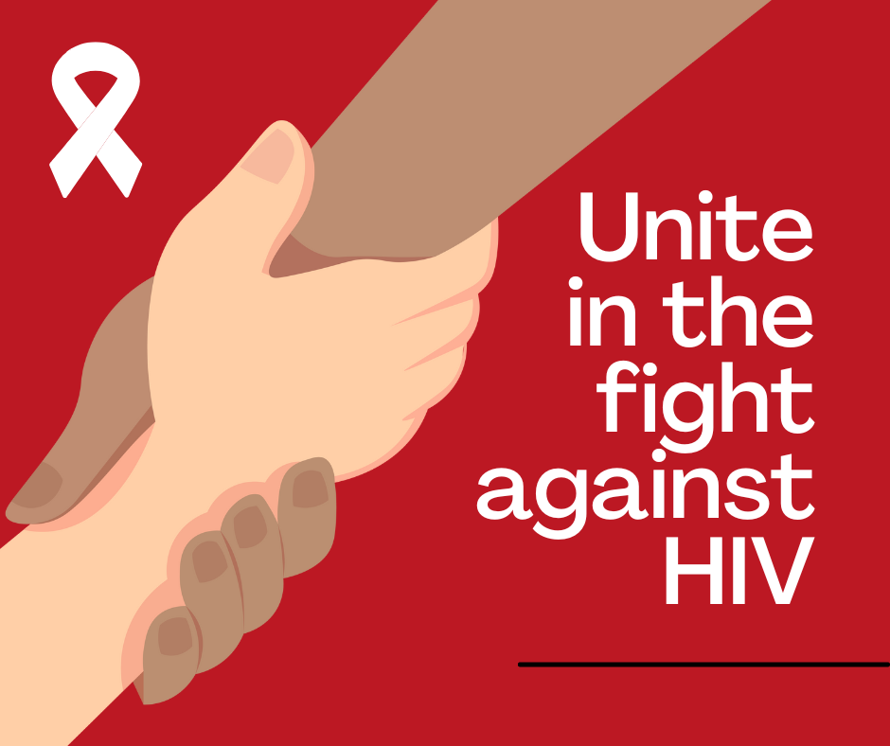  Click here to download | SUGGESTED CAPTION: Unite in the fight against HIV! Get screened: https://iwantthekit.org/

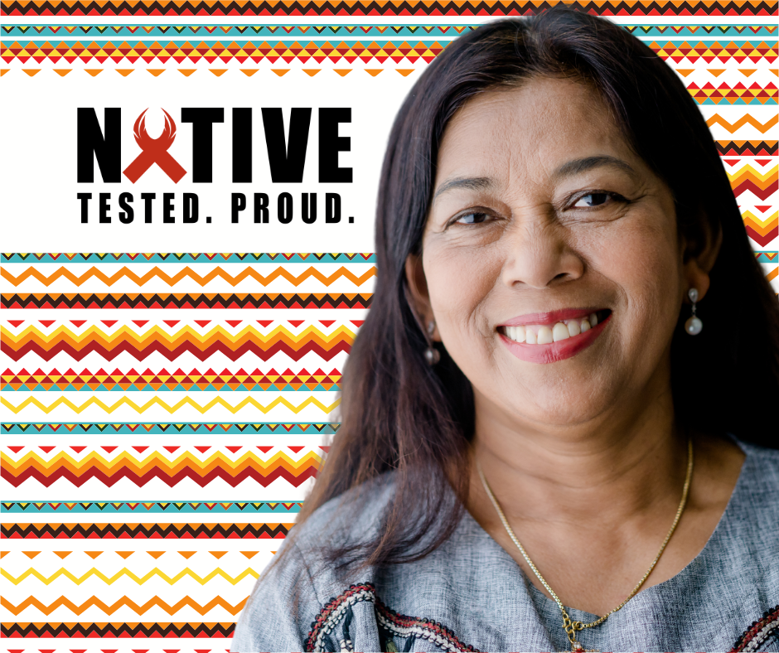  Click here to download | SUGGESTED CAPTION: Getting tested for sexually transmitted infection (STIs) and human immunodeficiency virus (HIV) shows that you care about yourself and the people you love. Get tested. Know your status.

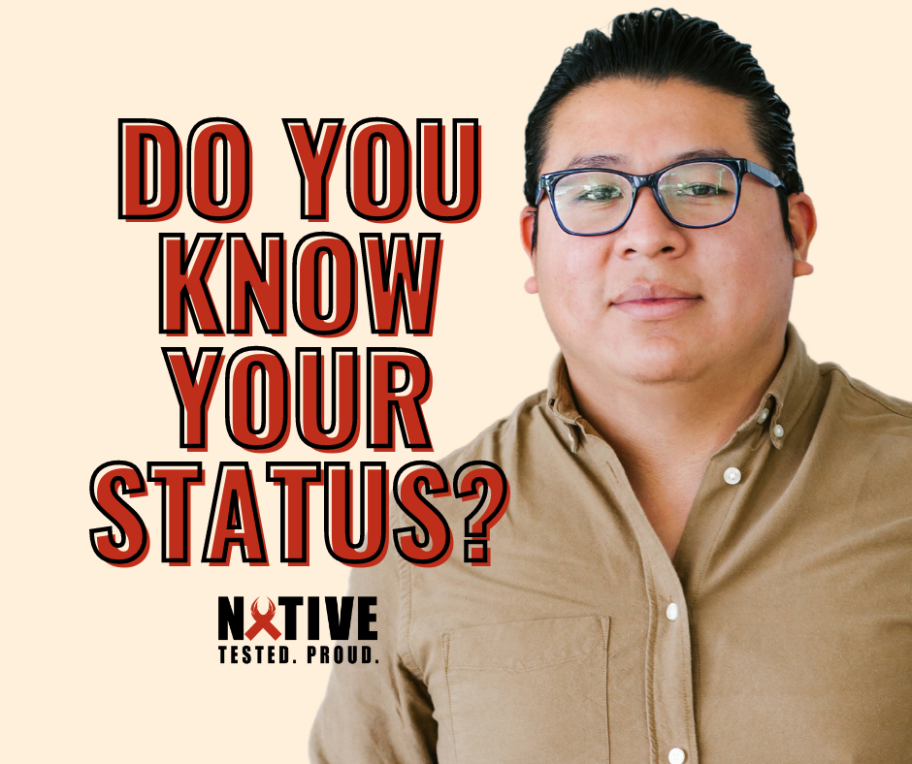  Click here to download | SUGGESTED CAPTION: Do you know your status? Getting tested for sexually transmitted infections (STIs) and human immunodeficiency virus (HIV) helps protect you and the people you love. Get tested. Know your status.

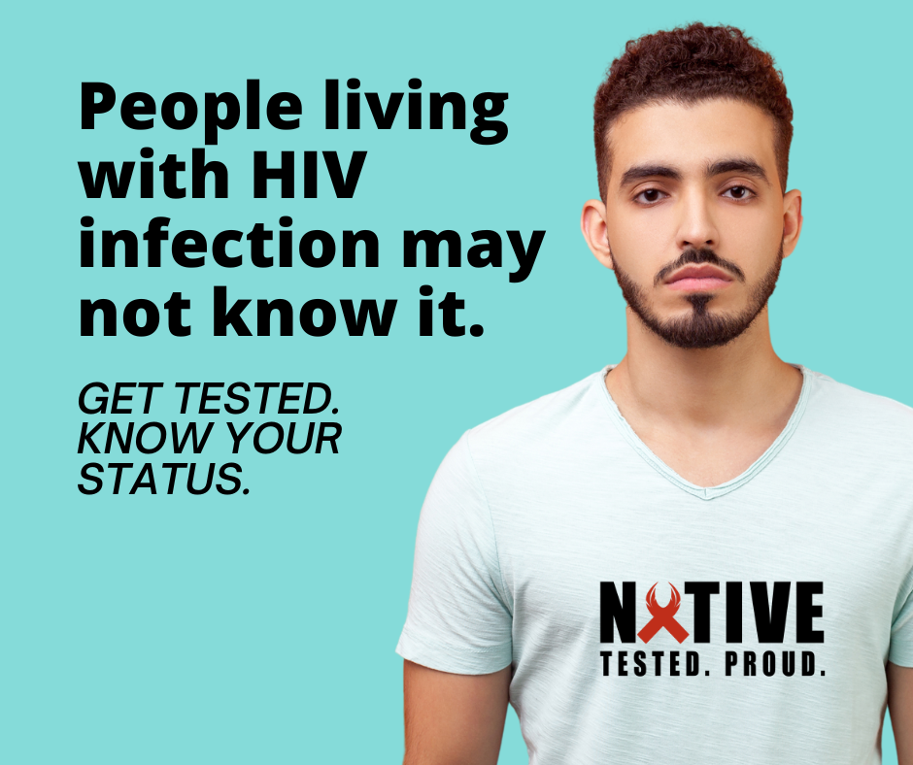  Click here to download | SUGGESTED CAPTION: People living with HIV infection may not know. Getting tested helps protect you and the people you love. Get tested. Know your status.

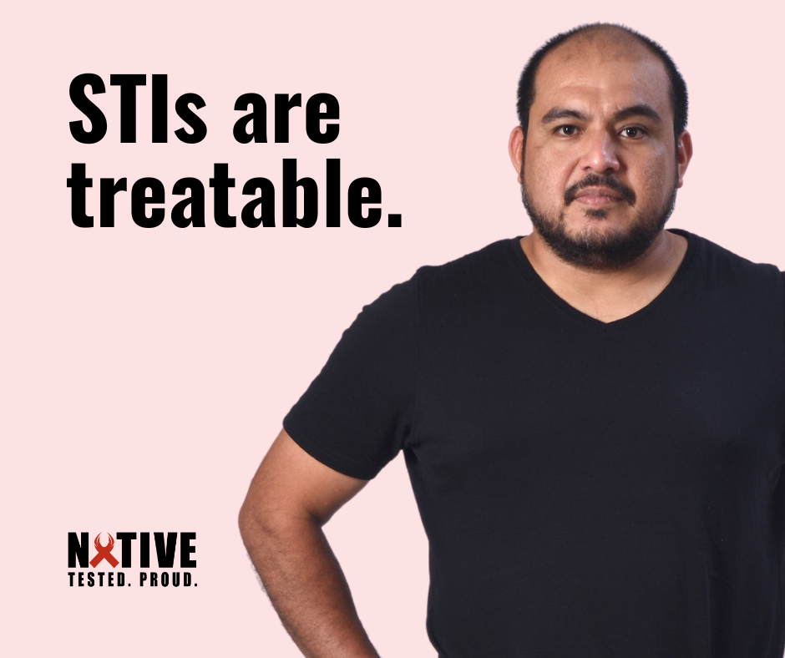  Click here to download | SUGGESTED CAPTION: Having open, honest conversations with your partner, using condoms, and getting tested are 3 ways to prevent STIs.

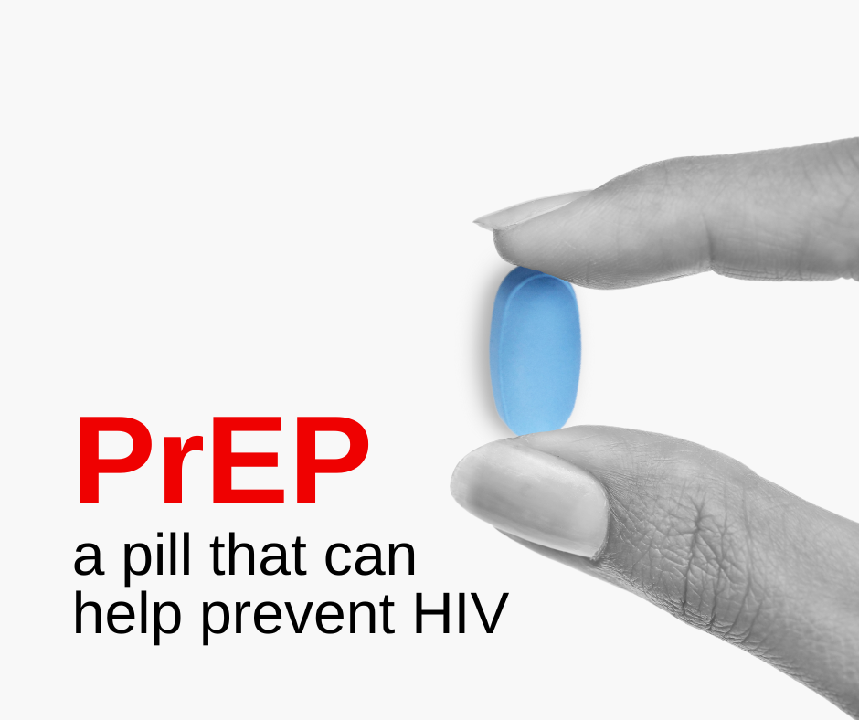  Click here to download | SUGGESTED CAPTION: PrEP, or pre-exposure prophylaxis, is medicine to prevent getting HIV from sex, injection drug use, or blood exposure. PrEP can help stop HIV from taking hold and spreading throughout your body. Talk to your healthcare provider if you think PrEP may be right for you.

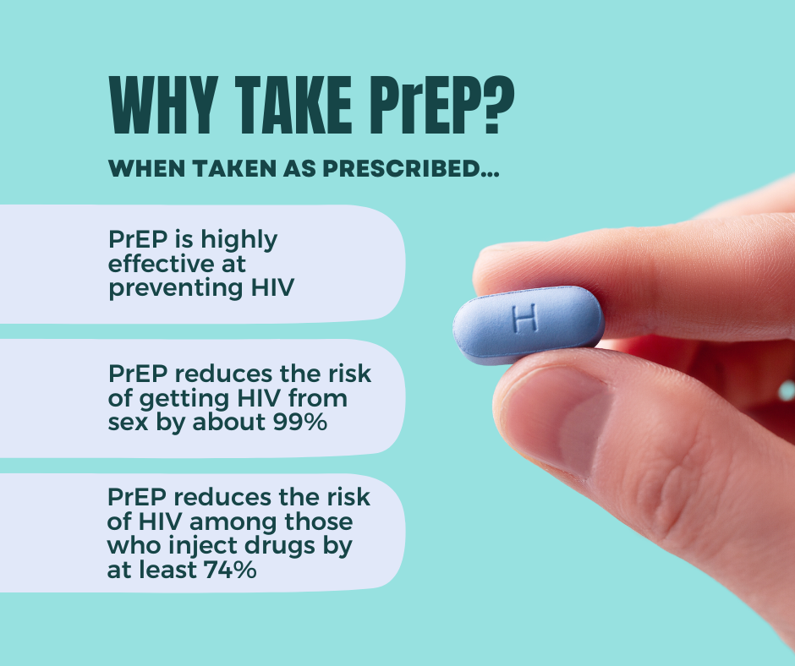  Click here to download | SUGGESTED CAPTION: Wondering if PrEP is right for you? Here are a few reasons why people take PrEP:  ➡ PrEP is highly effective at preventing HIV when taken as indicated  ➡ PrEP reduces the risk of getting HIV from sex by about 99% when taken as prescribed  ➡ Among people who inject drugs, it reduces the risk by at least 74% when taken as prescribed.  PrEP is much less effective when it isn't taken as prescribed.

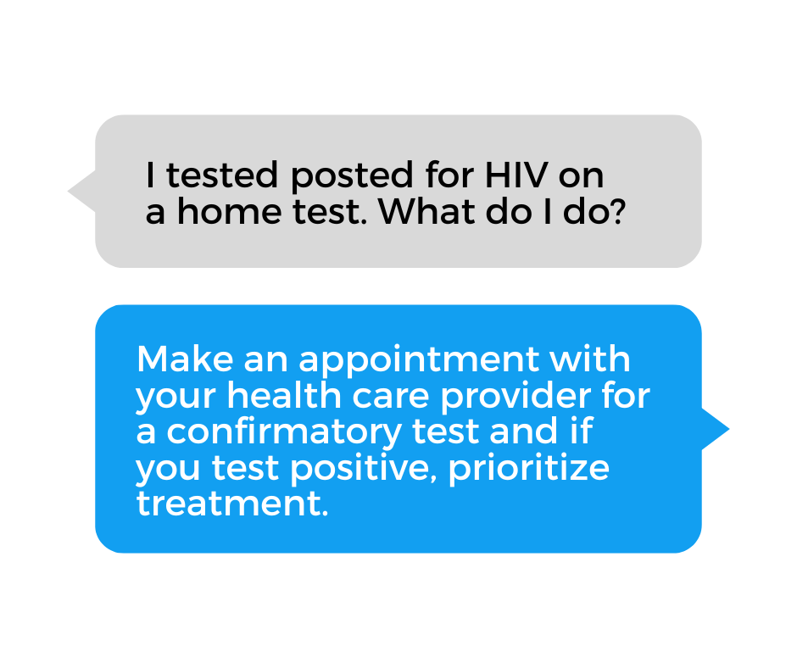  Click here to download | SUGGESTED CAPTION: If you test positive for HIV, it's important to start treatment as soon as possible. HIV can be treated effectively with today's treatments. Don’t delay making an appointment with your health care provider.

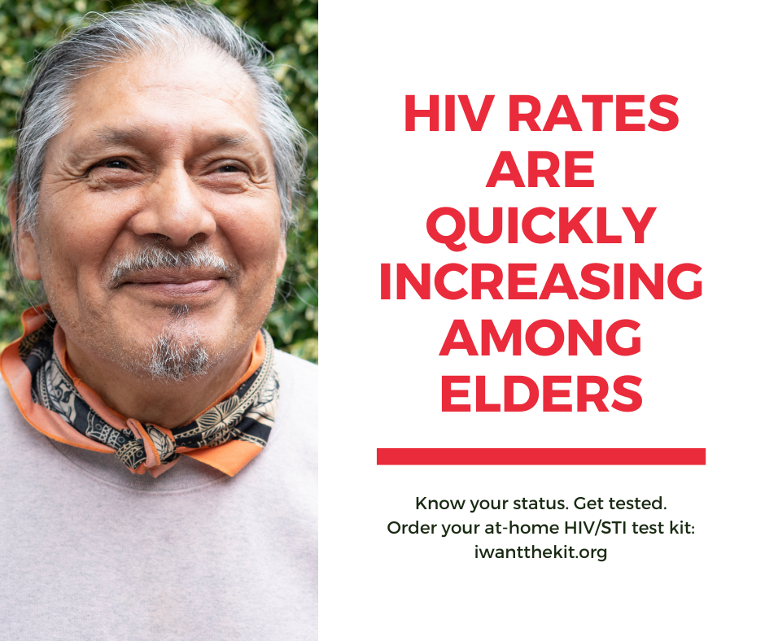  Click here to download | SUGGESTED CAPTION: There are many older adults who have HIV, but have not been diagnosed or are not aware of their HIV/AIDS status. It's important to get tested and know your status.  Order your free, confidential, at-home HIV/STI test kit at https://iwantthekit.org/ and talk with your healthcare provider about HIV prevention methods.

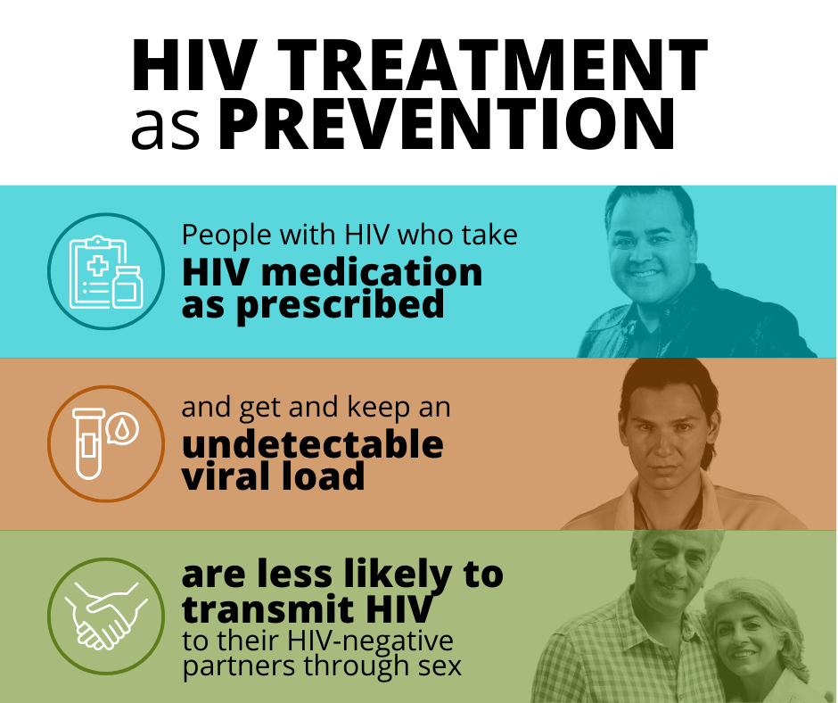  Click here to download | SUGGESTED CAPTION: Treatment as Prevention (TasP) means taking HIV medicine to prevent HIV through sexual activity. It is a highly effective way to prevent HIV infection. TasP works when a person with HIV takes HIV medicine exactly as prescribed and goes to follow-up care with their healthcare provider. Talk with your health care provider about the benefits of TasP.

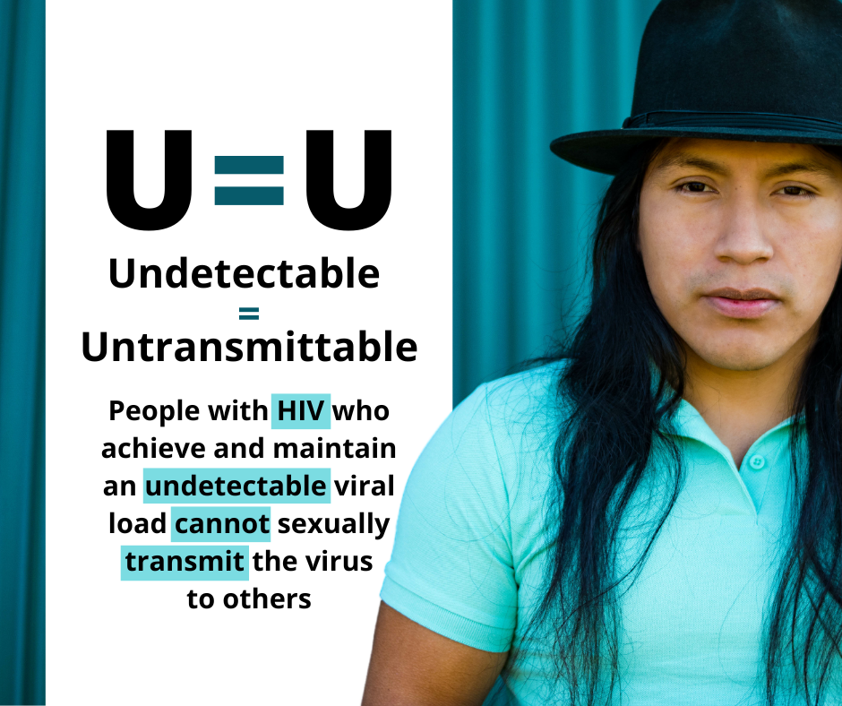  Click here to download | SUGGESTED CAPTION: U=U means that people with HIV have an amount of HIV in the blood stream that is undetectable by HIV tests. By taking daily medication and having undetectable HIV in the bloodstream, most people cannot transmit HIV to others. Talk with your health care provider about U=U.

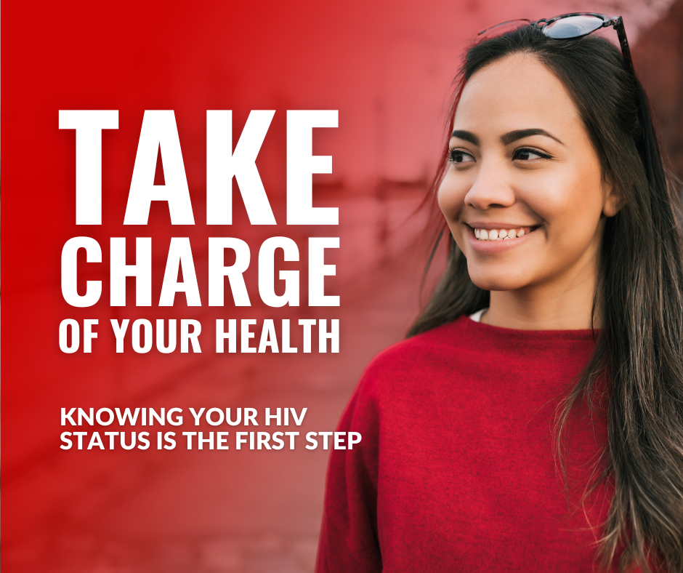  Click here to download | SUGGESTED CAPTION: Knowing your HIV status gives you the power to take charge of your health. Talk to your health care provider to learn more about HIV testing.

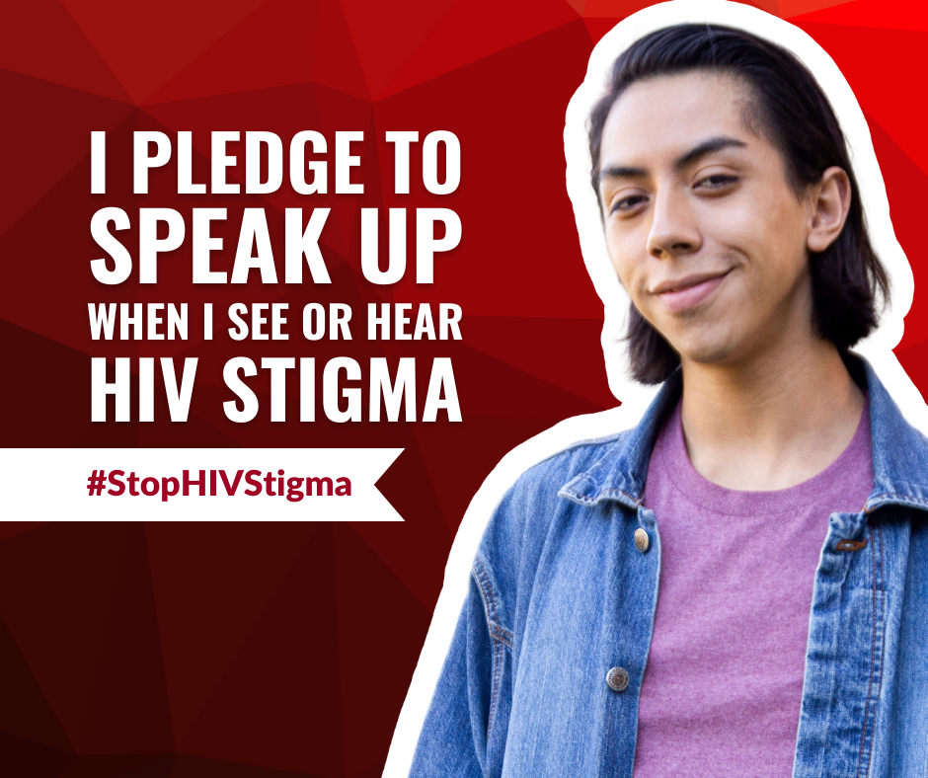  Click here to download | SUGGESTED CAPTION: We can all help end HIV stigma through our words and actions in our everyday lives. This AIDS Awareness Month, pledge to do your part to stop HIV stigma by speaking up and taking action against stigmatizing words or actions. If we all speak up against HIV stigma, we can stop HIV together.

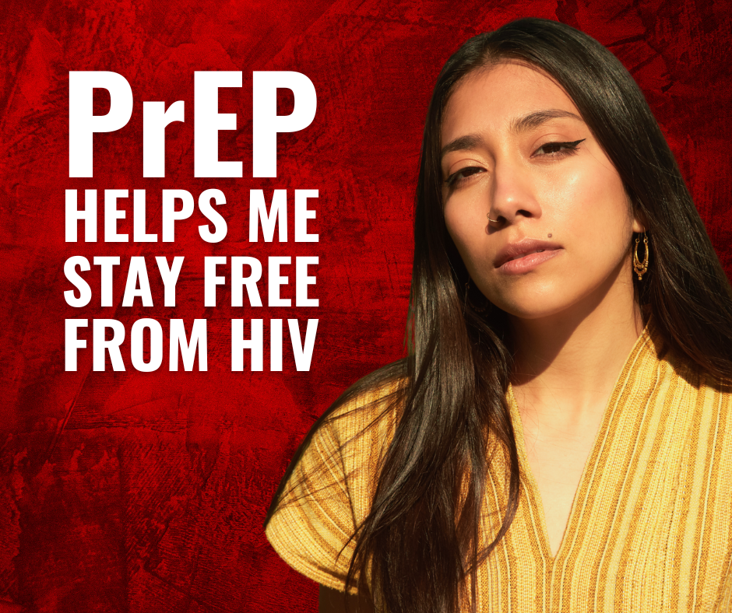  Click here to download | SUGGESTED CAPTION: If you don’t have HIV but are at risk, PrEP reduces your chances of getting HIV. Talk to your health care provider to find out if PrEP is right for you.
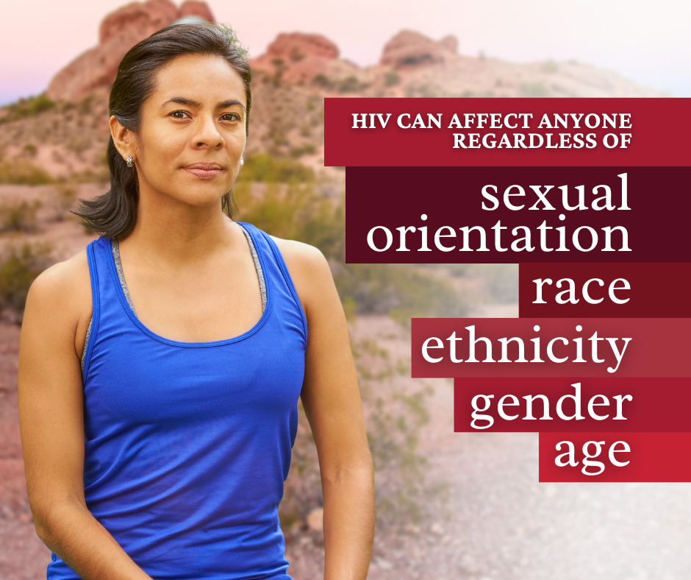  Click here to download | SUGGESTED CAPTION: Despite what many think, HIV can affect anyone – regardless of sexual orientation, race, ethnicity, gender, or age. It is recommended that everyone between the ages of 13 and 64 get tested for HIV at least once. People at higher risk should get tested more often.  Order your free, at-home HIV/STI test kit: https://iwantthekit.org/
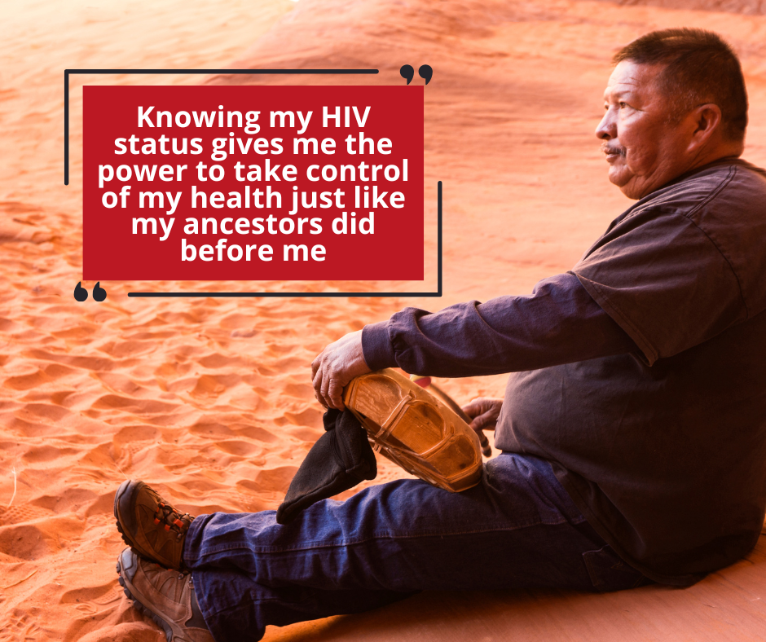  Click here to download | SUGGESTED CAPTION: You have the power to take control of your health. Know your status – get tested. Order your free, at-home HIV/STI test kit: https://iwantthekit.org/
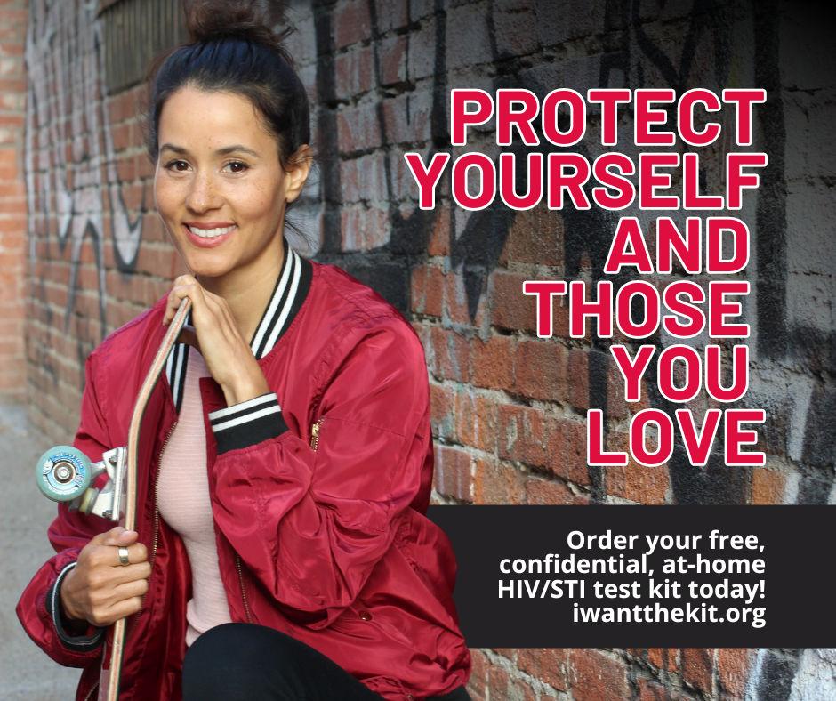  Click here to download | SUGGESTED CAPTION: Getting tested for HIV shows that you care about yourself and the people you love. Do your part to help end the HIV epidemic – get tested!  Order your free, at-home HIV/STI test kit: https://iwantthekit.org/
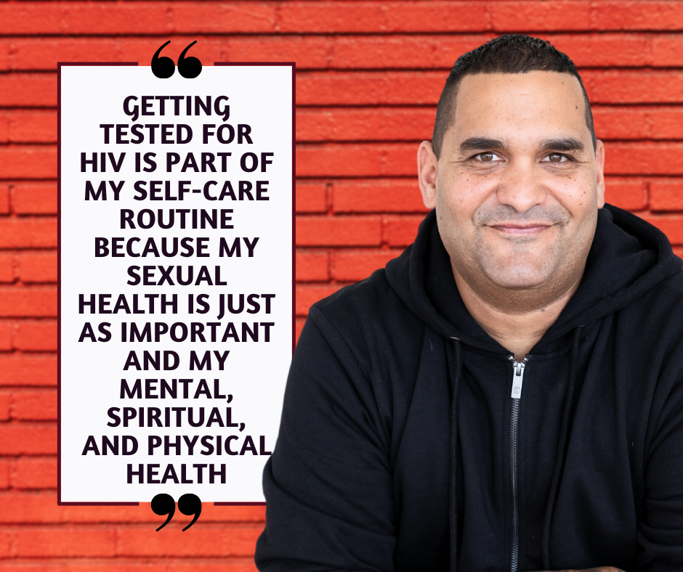  Click here to download | SUGGESTED CAPTION: Take care of yourself and make sure to include HIV testing as part of your self-care routine. There are more testing options than ever before.  Order your free, at-home HIV/STI test kit: https://iwantthekit.org/
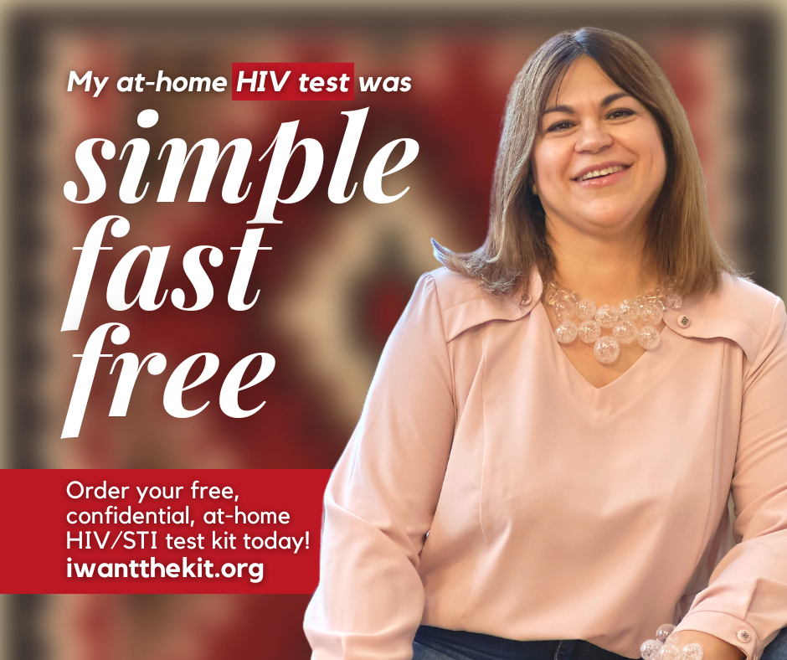  Click here to download | SUGGESTED CAPTION: Getting tested for HIV is simple, fast, and free! Order your free, at-home HIV/STI test kit: https://iwantthekit.org/

DOWNLOAD ALL HIV AWARENESS GRAPHICS HERE

