Toolkit for Express STI Services

Incident sexually transmitted infections (STIs) — gonorrhea, chlamydia, syphilis, and HIV — have rapidly increased in Indian Country. Of special concern is syphilis, which is disproportionately affecting American Indians and Alaska Natives relative to other racial/ethnic populations in the United States. Syphilis is more clinically challenging to diagnose and treat than other STIs, and its short and long-term sequelae can be life threatening for both adults and infants. Within this context, IHS/Tribal healthcare facilities in Indian Country need to enact comprehensive STI response efforts that consider pertinent testing, treatment, and prevention services and its systems capacity for such services.

This toolkit describes Express STI Services, which will enhance systems capacity for STI response efforts within an IHS/Tribal healthcare facility. Express STI Services refer to triage-based STI testing and treatment that are not contingent on direct clinical touchpoints with a physician or other clinician. Research shows that expedient STI services increase clinic capacity to see more patients and reduce time to treatment.

An Express STI Service requires:

(1) Assignment of both clinical and non-clinical staff for intake, triage, and testing processes
(2) Availability of a standing order for STI testing
(3) Review of STI lab results by the supervising or ordering clinician
(4) Notification to the patient of STI lab results
(5) Linkage to treatment for patients with STIs
(6) Treatment for patients with STIs, including by a standing order for STI treatment

Importantly, each IHS/Tribal healthcare facility has its contextual and logistical elements that contribute to the local application of Express STI Services. Within this toolkit are key considerations from the National Association of County and City Health Officials (NACCHO) and the Centers for Disease Control and Prevention (CDC) regarding the purpose and the implementation of these services. Supplemental materials include sample policies and workflows that can be adapted at the discretion of each IHS/Tribal healthcare facility. Further, IHS/Tribal healthcare facilities may access clinical and administrative trainings, technical support, and material resources for Express STI Services and other systems needs related to STI response efforts.

Components of an Express STI Service Visit

Intake

The purpose of the intake for an Express STI Service visit is to determine a patient’s eligibility for STI testing without direct clinical touchpoints with a physician or other clinician. Eligibility can be assessed via paper or digital forms and/or phone or in-person interview by a non-clinician staff person. Eligibility criteria must be established to direct triage of the patient to an Express STI Service visit or alternate visit type. Whether an intake is conducted by form or interview, the patient is queried for symptoms of an STI, suspected and confirmed STI exposures, and activities that can lead to STI exposure.
Express STI Services are available to asymptomatic patients who can provide legal consent for STI-related health care, including testing, treatment, and prevention. Patients are typically ineligible for Express STI Services if they are experiencing symptoms of an STI, which may include: generalized rash; genital, rectal or oral lesions; painful urination; urethral, genital, or anal discharge; pain with sexual intercourse; fever; lymphadenopathy; and/or sore throat. An IHS/Tribal healthcare facility may elect to permit Express STI Services for symptomatic patients in combination with expedited care linkage with a clinician for further evaluation and treatment.

A patient’s privacy is an essential component of a safe, patient-centered risk assessment for STI exposure or infection. Privacy is relevant to a paper or digital intake completed by the patient in a waiting room or via interview by a non-clinician staff person.

Triage

The purpose of the triage for an Express STI Service visit is to identify if symptoms and/or suspected/confirmed exposures are present. If symptoms and/or suspected/confirmed exposures are present, the patient is linked to an outpatient visit with a clinician.

Patients don’t always report symptoms on digital or paper risk assessments. A best practice is to conduct a brief in-person symptom screening prior to testing to confirm the patient is triaged appropriately.

The characteristics of the risk assessment for STI exposure or infection define the time required to complete intake and triage steps of Express STI Services. An IHS/Tribal healthcare facility may develop a risk assessment that can be completed in five minutes or less so as to prioritize time-based efficiency for Express STI Services. Another facility may elect to conduct a thorough risk assessment that requires a longer intake for Express STI Services.

If a clinic turns away a high number of patients every day, the focus can be centered on reducing patient wait time and visit time to accommodate more patients in the clinic. However, if only one bathroom is available for patients to self-collect urine and swabs, clinics might need to continue relying on providers to collect samples. Another clinic might want to prioritize patients who are unlikely to return for clinics, so point-of-care (POC) testing that reduces turnaround times might be most important.

Staffing and Patient Flow

Staffing models largely dictate how express STI testing is implemented. A common goal of implementing express visits is to maximize “top-of-license” strategies. Since express services are, by definition, visits that do not include clinical examinations, they tend to use RNs, LPNs, and MAs. Non-licensed staff may also be part of patient navigation. Express STI services will require multidisciplinary support among clinical staff including standing orders and cross-coverage of screening, specimen collection and notification of results.

Offering express services have been shown to increase the number of patients a clinic is able to see per day. Patient volume, staffing and facility layout will determine a clinic’s capacity and turnaway rate. Some clinics may choose to limit their express option to specific days/times.

When determining a schedule for express services, clinics should consider the days and times that visits are most utilized by the populations they serve, as well as the average length of an express vs non-express visit. Volume and capacity may change based on staffing, regular variations in testing practices, partner services, and treatment for those who test positive.

In addition to staffing considerations, physical space and layout of the clinic will determine workflow. These variables may include privacy for triage, waiting room size, availability of additional exam rooms, location and number of single-occupancy bathrooms, as well as counter space to hold specimens.

Testing

What tests to include

The typical package of testing for express STI services include gonorrhea, chlamydia, syphilis, and HIV. Pregnancy testing should also be added as part of the testing package.

Point-of-care testing

POC testing provides opportunities for same visit diagnosis and treatment and enables staff to contact partners immediately to bring them in for screening and treatment. True POC tests exist for HIV, HCV and syphilis, while gonorrhea and chlamydia have near POC tests.

Self-Collection and Lab Testing

Self-collection of specimens has benefits for patients and providers. There is strong evidence that patients are able to accurately collect samples by themselves, given proper instructions. Evidence also shows high patient satisfaction, with patients finding self-collection easy and comfortable. Because express patients don’t see providers, most clinics implement self-collection protocols for swabs and urine for gonorrhea and chlamydia and have clinical staff collect serum for HIV and syphilis. Considerations include:

• Physical space: Clinics should have an adequate number of single-occupancy bathrooms and clear patient instructions for collection and what to do with the samples.
• Instructions: It is important for clinics to include body-specific, rather than gender-specific language. Instructions for what to do with samples will be specific to each clinic.

Consideration of priority populations

- Pregnant patients: Express STI testing should not be a substitute for prenatal care. Pregnant patients should have scheduled follow up visits with a prenatal care provider. Pregnant people with a substance use disorder (SUD) may avoid prenatal care if there is a perception it will lead to punitive measures.
- Substance use disorder: People (including pregnant patients) with SUD may avoid express STI screening if there is a perception it will include drug testing or lead to punitive measures. Staff should be clear on what tests are included in the testing package and that urine drug screening is not included. Staff should be prepared to have conversations on SUD in a non-judgmental way. See Plan of Safe Care Toolkit link for more information:
https://www.indiancountryecho.org/plans-of-safe-care-toolkit/
- Patients experiencing domestic violence. These patients are at risk for having physical injury and will need additional support services. If domestic violence is disclosed by the patient at triage, the patient should be considered for a provider visit.
- Sexual Assault: Express STI testing should not be considered for patients that have been sexually assaulted.
- Adolescents: In most states, minors are able to seek STI testing without parental consent. This should be considered alongside agency and facility-based guidance.
https://www.guttmacher.org/state-policy/explore/minors-access-sti-services

Validation

The Recommendations for the Laboratory Based Detection of Chlamydia trachomatis and Neisseria gonorrhoeae, 2014 details testing modalities and performance of provider and self-collected testing. For extragenital testing, no platform is approved for self-collected swabs, whether collected in the clinic or elsewhere, though extragenital testing platforms were cleared by the FDA in 2019 for clinician-collected testing. The only tests that are FDA cleared for self-collection in a clinic setting are urine and vaginal samples as listed in the Laboratory guidelines. CLIA-regulated laboratory validation requirements for self-collection of genital and extragenital testing need to be reviewed and addressed by the clinic’s partner laboratory if the testing being undertaken is not FDA-cleared for this purpose.

Unless test specimens are processed in the clinic, billing for extragenital gonorrhea and chlamydia tests is usually performed by the laboratory performing the NAATs. Laboratories will use the current procedural terminology (CPT) codes for gonorrhea and chlamydia tests: 87491 (chlamydia) and 87591 (gonorrhea). NAATs performed on the same date but from different anatomic locations will need separate orders for each extragenital location, or sample. The modifier “90” indicates that the test is outside of the organization (reference laboratory) as “87491-90” for example.

Notification and Treatment

Prompt notification and treatment are essential for treating patients and reducing ongoing STI transmission. Best practice is to offer multiple avenues for results notification (e.g., a results phone line and an online portal) so patients can access results in a way that best meets their preferences.

Notification and Partner Services

In addition to phone calls and letters, several studies have been conducted to evaluate internet partner services (IPS) outcomes, which may be necessary in settings where DIS support and PHN shortages may result in notable delays in notification, treatment, and contact tracing.

IPS can be used in ways that are fully HIPAA compliant. Studies on IPS include use of email, social networks, and text messaging. These interventions have been documented to link patients to care that would have otherwise not been located, did not require additional staff time, and allowed for rapid partner notification communication. Another study found that the use of social networks augmented traditional efforts by allowing DIS to reach partners more quickly, especially among those individuals who may frequently change phone numbers or addresses, while also aiding in the identification of sought-after partners.

A structured literature review of published studies about technology for STI/HIV partner services found that the use of technology resulted in additional partners notified, screened, or tested; the identification of new positive cases; and contact with partners who otherwise would not have been notified of their STI/HIV exposure. Furthermore, the integration of technology provided other programmatic advantages such as improved operational efficiencies, reaching partners, and cost savings.

See supplements for CDC templates on procedures, texts and emails that can be used to reach out to STI contacts without violating HIPAA.

Treatment

Empiric and directed treatment for bacterial STIs is a core component of Express STI Services. These treatment services may occur through same-day care linkage to a healthcare professional for a medical visit or via a nurse- or pharmacy-drive standing order protocol, whereby the nurse or pharmacist provides appropriate empiric or targeted treatment of gonorrhea, chlamydia, or syphilis and the patient is subsequently linked to care for a medical visit in subsequent days or weeks. Order sets with up-to-date CDC standards for STI treatment can be beneficial to expeditious treatment by healthcare professionals or via a standing order protocol (REF to SO Protocol below).

Chemoprophylaxis after suspected or known HIV exposures, also known as HIV Post-Exposure Prophylaxis or PEP, is another important component of Express STI services. This preventive treatment service may be offered via expeditious care linkage to a healthcare professional for a medical visit within 72 hours of the incident exposure. Order sets with up-to-date CDC standards for HIV PEP can be beneficial to expeditious treatment by healthcare professionals.

EPT

Expedited Partner Therapy (EPT) is the clinical practice of treating partners of heterosexual patients with a known or suspected diagnosis of GC/CT/MPC/NGU without performing an exam on the partner. Treatment can be achieved by 1) providing medication in the clinic without an exam, 2) issuing the medication or a prescription to the patient to give to the partner, 3) delivery of medication to the partner in the field by clinic staff. Treatment of non-beneficiaries with EPT is allowable and encouraged. (Indian Health Manual. Part 2. Chapter 4. Appendix E: Statutes That Allow Health Services to Be Provided to Ineligible Individuals at IHS Facilities. Sec.813(c) IHCIA. http://www.ihs.gov/IHM/index.cfm)

EXPEDITED STD MANAGEMENT

- Patient-Delivered Partner Therapy (PDPT). The most common type of EPT; the patient delivers the medication or a prescription to his/her sex partner(s).
- FDT – Field-Delivered Therapy. Treatment of patients with a positive test result and/or partners (with or without testing) in the field by an appropriately trained clinic staff (i.e. DIS, RN, LVN, Outreach worker).

Counseling on HIV Chemoprophylaxis

Along with HIV PEP, HIV Pre-Exposure Prophylaxis (PrEP) is an essential HIV preventive treatment service for patients seeking Express STI Services. All patients seeking Express STI Services require counseling on HIV PrEP and PEP, and linkage to care for these services (REF).

Table of Contents: Supplements

General
- Policy and Protocol for STI Testing/Treatment (NAACHO report) page 8
- Nursing and/or Pharmacy Standing Order for STI Testing and Treatment pages 9-14
- Wind River Express STI Access Policy page 15

Workflow
- Registration Desk point of contact workflow page 16
- Triage Nurse point of contact workflow page 17
- Laboratory point of contact workflow and policy from NNMC page 18-21

Express STI Risk Assessment
- Sample form: file (nzshs.org) page 22

Self-Testing
- Clinical procedure for collection of pharyngeal, rectal, vaginal, phlebotomy pages 23-25
- self-collection-oral-poster.pdf (nyc.gov) page 26
- self-collection-anal-poster.pdf (nyc.gov) page 27
- self-collection-vaginal-poster.pdf (nyc.gov) page 28
- Chlamydia azithromycin/doxycycline flowchart page 29
- PCN treatment procedure for syphilis pages 30-31
- Anaphylaxis Management pages 32-33
- Ceftriaxone treatment procedure for gonorrhea page 34

SAMPLE POLICY AND PROTOCOL
EXPRESS STI CLINIC SERVICES POLICY:

It is the policy of _______________________ clinic to provide the appropriate level of care to each client depending on their symptoms, risk factors, and personal concerns.
PURPOSE: To provide a procedure for triaging appropriate clients into “express” lab testing and/or treatment.
PROTOCOL: After the client completes a history, the receptionist will review the form. If the history is negative for risk factors and the client denies symptoms, the client will be offered the option of “express” services. However, the client maintains the option to request comprehensive services.
Nurses and trained and approved personnel may conduct “express” testing. Only nurses or other clinicians may do comprehensive exams.
If the assessment form reveals one or more high-risk criteria and the client has no symptoms, the express assessment nurse or other trained and approved staff may collect a urine, throat, vaginal, and/or rectal specimen from the client for gonorrhea and chlamydia testing and have the client’s blood drawn for HIV and syphilis. (Depending on local syphilis rates, the patient may be offered prophylactic treatment for syphilis.)
“Express” services also include immunizations, repeat Bicillin injections, pregnancy tests, treatment of partners who accompany patients, asymptomatic contacts seeking treatment, etc.
If the Assessment form reveals one or more high-risk criteria and the client has symptoms, the client will receive a comprehensive STI evaluation and appropriate lab testing and treatment.
High risk clients who require an exam regardless of symptoms are persons who are contacts to syphilis, MSM, injecting drug users, and persons who exchange money and/or drugs for sex, or people who may be pregnant.
The lab will perform a stat RPR or rapid point of care syphilis test and a rapid HIV test if available. The client is instructed to remain in the clinic until test results are available.
CLIENT EDUCATION: Results may be given by clinicians, nurses or other trained clinic staff. The client is instructed to call the clinic in 7-10 days for GC/CT and traditional, confirmatory HIV results. Condoms and lube are offered to all clients. Although counseling is abbreviated, it should include – 1) how to take the medication, 2) symptoms of more serious infection (e.g., pelvic pain in women, testicular pain in men, or fever in men or women), 3) seeking prenatal care as soon as possible if pregnancy is confirmed or possible, 4) abstain from sex for at least seven days after completing treatment, 5) ensure all partners have been treated, 6) seek clinical services for re-testing three months after treatment. Pharyngeal GC treatment requires test of cure 1-2 weeks post-treatment

STANDING ORDER: SEXUALLY TRANSMITTED INFECTION TESTING AND TREATMENT
BY NURSING AND PHARMACY

PURPOSE: To permit nurses and pharmacists to screen for bacterial sexually transmitted infections (STIs), HIV, and hepatitis C virus (HCV) and to treat bacterial STIs among American Indian/Alaska Native (AI/AN) populations accessing medical services within Indian Health Service (IHS) clinical facilities or field sites serviced by IHS staff. Bacterial STIs relevant to this pathway are gonorrhea (GC), chlamydia (CT), syphilis, and trichomoniasis.
RATIONALE: Due to high incidence and prevalence of treatable STIs within Indian Country – infections that propagate significant morbidity and mortality when undiagnosed and untreated – expanded access to STI testing and treatment are needed for AI/AN adolescents and adults.

POLICY STATEMENT:
This policy and standing order permits nurses (outpatient or Public Health Nurse/PHN) and/or pharmacists to provide:
1. Screening testing for chlamydia, gonorrhea, syphilis, HIV, and HCV among adolescents and adults engaging in any type of sex, or upon an individual’s request for STI testing regardless of sexual history.
2. Treatment for suspected or confirmed bacterial STIs (including GC, CT, early to early latent syphilis, and trichomoniasis) among adolescents and adults per the current Centers for Disease Control and Prevention (CDC) Guidelines.
3. Resources on sexual health, HIV pre-exposure prophylaxis (PrEP), and HIV post-exposure prophylaxis (PEP) for adolescents and adults.¹
4. Screening of adolescents and adults for intimate partner violence (IPV), sexual exploitation, and substance use/misuse during sex.
ASSESSMENT:

- Eligibility and criteria to determine the situation or condition for which the standing order may be carried out.
- Screening testing pathway:
- Patient is asymptomatic, aged ³14 years,² eligible for clinical services within the IHS.³ and:
- Requests STI screening due to engagement in sex without use of barrier methods to prevent STI exposures.
(OR)
- Reports sexual contact with an individual with known STI(s).
(OR)
- Requests STI screening (regardless of disclosed sexual history).
(OR)
- Is eligible for routine STI screening based on age, risk factors per sexual history⁴, and/or other medical indications⁵.
- Patient is located in the outpatient clinic, the pharmacy, or a field site.
- Treatment pathway:
- Aged 14 years and their reported sexual contact(s) aged14 years, eligible for clinical services within the IHS and:
- Patient has positive screening or diagnostic laboratory testing for STI(s).
(OR)
- Patient is identified in a public health report as a sexual contact to individual(s) with known STI(s).
(OR)
- Patient is symptomatic, but does not have a positive screening or diagnostic laboratory testing for STI(s) or is identified in a public health report as a sexual contact to individual(s) with known STI(s).
(OR)
- Patient is asymptomatic, reports risk factors per sexual history, and experiences barriers to future care linkage for STI treatment.
- Patient is located in the outpatient clinic, the pharmacy, or a field site.

PROCEDURES BY PATHWAY:

- Screening testing pathway for asymptomatic adolescents and adults:
- Patient requests STI screening from nurse or pharmacist.
(OR)
Patient is offered STI screening by nurse or pharmacist.
- Patient is queried for signs and symptoms of bacterial STIs, HIV, and HCV, and knowledge of sexual contacts with known/suspected STIs.^{78,9}
- If signs, symptoms, and exposures are absent, patient is offered comprehensive screening tests for bacterial STIs, HIV, and HCV.
- Patient also receives urine pregnancy testing if has uterus and ovaries and is premenopausal.
- Refer to Table 1 for laboratory orders.
- Refer to Supplement # for procedural logistics involving collection of bodily fluid specimens.
- Patient receives counseling on HIV PrEP/PEP.
- Patient is screened for IPV, sexual exploitation, and substance use/misuse during sex.
- Identify personnel to communicate positive results to patients and to coordinate care for treatment (the clinician ordering under the protocol or the authorizing provider).
- Treatment for adolescents and adults with confirmed STI(s) or suspected STI exposure(s)¹⁰
- Patient requests STI treatment from nurse or pharmacist.
(OR)
Patient is contacted about STI treatment by nurse or pharmacist.
- Patient is queried for signs and symptoms of bacterial STIs, HIV, and HCV, and, if not already asked, knowledge of sexual contacts with known/suspected STIs.
- Patient receives urine pregnancy testing if has uterus and ovaries and is premenopausal.
- Identify personnel to communicate result of pregnancy test to the patient and coordinate pre-natal care if result is positive.
- If an STI is already confirmed:
- Patient is administered the appropriate definitive treatment regimen for the bacterial STI(s) of concern.
- Refer to Supplement for procedural logistics involving medication administration.
- If exposure to an STI is suspected but not yet confirmed with laboratory testing:
- Screening testing is obtained for the bacterial STI(s) of concern and for all other STI(s).
- Patient is administered the appropriate empiric treatment regimen for the bacterial STI(s) of concern.
- Refer to Supplement for procedural logistics involving medication administration.
- A communicable disease investigation is performed and documented in the electronic health record.
- Documentation includes signs and symptoms, STI testing results if already completed, pregnancy testing if performed, allergies, treatments administered, counseling provided, sexual contacts identified, and EPT dispensed.
- Reports for cases of positive STIs are submitted via the appropriate state reporting system.
- Patient receives counseling on HIV PrEP/PEP.
- Patient is screened for IPV, sexual exploitation, and substance use/misuse during sex.
- If not yet done before time of treatment, patient is linked to ambulatory care for further evaluation and management by a clinician.
- Nurse or pharmacist contacts designated provider or other clinician immediately if concerning signs or symptoms of STIs or refers the patient to the emergency department.
- All sexual contacts are contacted for testing and treatment as outlined in this policy for primary contacts.

APPENDIX
Procedure for laboratory specimen collection
Procedure for medication administration:
- Administration of benzathine penicillin G
- Administration of ceftriaxone
- Administration of oral medications
- The nurse or pharmacist orders oral medications under EHR standing order and a designated provider as the ordering prescriber. Outpatient pharmacy will be contacted to review for appropriateness and process standing order and will “release without signature.”
- The patient is instructed to pick up the medication from the pharmacy or to report to the PHN office.
(OR)
The medication is picked up from the pharmacy by PHN and delivered to the patient in the field.
- The nurse or pharmacist documents an EHR note as described below.
- Administration of any medication is documented in the patient’s medical record by the nurse or pharmacist and must include name of medication, dosage, route, site, and date/time of administration.
- Nurse or pharmacist contacts designated provider or other clinician immediately if any concerning signs/symptoms of severe local or systemic reaction to administered medication(s) (OR) refers the patient to the emergency department.
- For directly observed therapy or nurse/pharmacist-administered benzathine penicillin G, documentation of the patient’s response to medication administration is required.
- This Standing Order and plan of care is to be referenced in documentation when applicable.
- The completed EHR note is routed for co-signature to the designated provider.

TABLE 1. Laboratory Orders to Screen for Sexually Transmitted Infections Among Adolescents and Adults

 | Specimen type | Screening Test
Chlamydia | Urine (and/or oral swab and/or vaginal swab and/or rectal swab)¹² | Nucleic Acid Amplification Test
Gonorrhea
Syphilis | Serum | Syphilis algorithm using treponemal test (EIA, TPPA) or nontreponemal test (RPR)
HIV | Serum | Fourth-generation HIV Ag/Ab test (with reflex testing if possible)
HCV | Serum | Hep C Antibody w/reflex to RNA

TABLE 2. Point of Care Orders to Screen for Sexually Transmitted Infections Among Adolescents and Adults

 | Specimen Type | Screening Test
HIV | Oral fluid or fingerstick (OraQuick)  Fingerstick (INSTI)  Fingerstick (Alere) | Second-generation HIV Ab (IgG) test  Third-generation HIV Ab (IgM/IgG) test  Fourth-generation HIV Ag/Ab test
HCV | Fingerstick (OraQuick) | Hep C Antibody
Syphilis | Fingerstick (Health Check) | Treponemal Antibody
HIV/  Syphilis | Fingerstick (Chembio) | Second-generation HIV Ab (IgG) test/Treponemal Antibody

TABLE 3. Medications to Treat for Sexually Transmitted Infections Among Adolescents and Adults

Condition | Medication
Chlamydia (CT) | CT  PO Doxycycline 100mg BID for 7 days  CT during Pregnancy  PO Azithromycin 1g in a single dose  Expedited Partner Therapy (EPT)  PO Azithromycin 1g in a single dose
Gonorrhea (GC)*  *If chlamydial infection has not been excluded, treat for CT. | GC of the cervix, urethra, pharynx, or rectum  <150 kg – IM Ceftriaxone 500mg in a single dose  >150 kg – IM Ceftriaxone 1g in a single dose  EPT  Cefixime 800 mg in a single dose (if Ceftriaxone 500 mg IM in a single dose cannot be given)  GC/CT coinfection with cephalosporin allergy  IM Gentamicin 240mg in a single dose  PLUS  PO Azithromycin 2g in a single dose
Primary, Secondary, and Early Syphilis | Primary, Secondary, and Early Latent Syphilis Among Adults  IM Benzathine penicillin G 2.4 million units in a single dose  Nonpregnant Persons with Penicillin Allergy  PO Doxycycline 100mg BID for 14 days  OR  PO Tetracycline 500mg QID for 14 days  Pregnant Persons  IM Benzathine penicillin G 2.4 million units in a single dose  A second dose of IM Benzathine penicillin G 2.4 million units can be administered a week after the first dose.
Late, Unknown Duration Syphilis | Late, Unknown Duration Syphilis Among Adults  IM Benzathine penicillin G 2.4 million units: 3 doses in 1 week intervals  Nonpregnant Persons with Penicillin Allergy  PO Doxycycline 100mg BID for 28 days  OR  PO Tetracycline 500mg QID for 28 days  Pregnant Persons  IM Benzathine penicillin G 2.4 million units: 3 doses in 1 week intervals  Doses must be given no later than 9 days apart, otherwise full course of therapy should be repeated.

REFERENCES:
Centers for Disease Control Sexually Transmitted Infection Treatment Guidelines

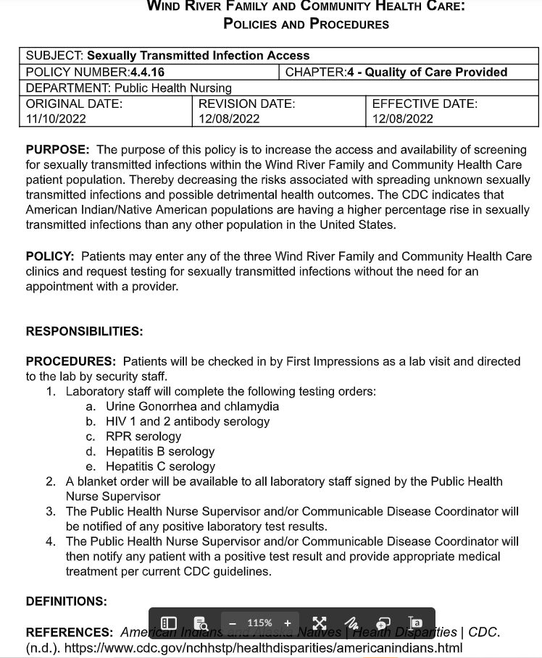
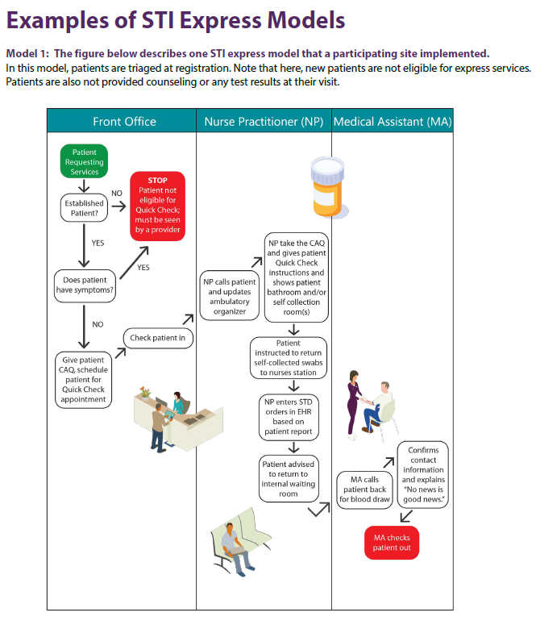

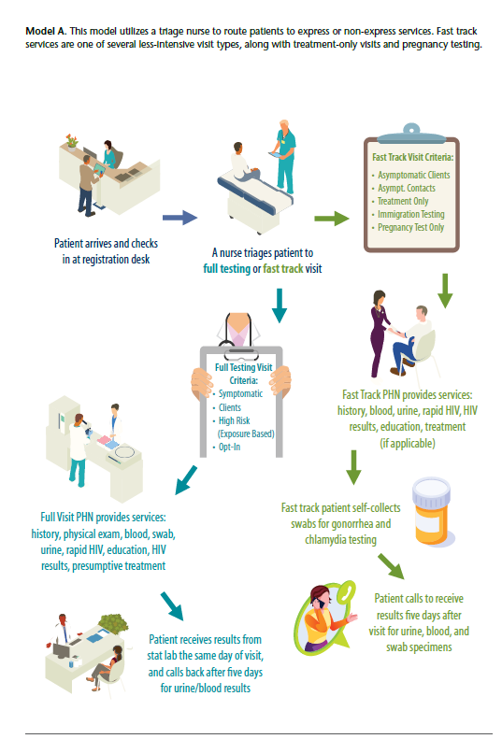

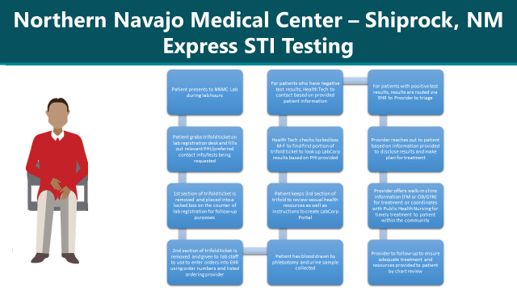

NNMC Express STI context and forms

- A patient presents directly to the Laboratory during operating hours, requests testing (must be asymptomatic or will be directed to go to a clinic for an evaluation).
- They fill out a paper form (I've attached) with relevant PHI, preferred contact info, and what tests they are requesting (right now just 3 options).
- 1st third of the perforated paper is removed & placed in a locked box in the lab (w PHI, to be used to look for & track test results as below). Middle third is removed & given to the lab to use to enter the orders into the EHR using order numbers & listed ordering provider (this can be anyone who doesn't mind excess notifications they can ignore or erase, we are NOT using EHR notifications of results as our primary means to follow up these results).
- Patient keeps the last/Right third of the ticket, they can follow the results themselves on Labcorp patient portal (at least for adults) and/or they can call the number listed if they haven't heard the results within 2 weeks (rings to a health tech in the Community health department who was previously responsible for giving covid test results).
- 2-3 times per week, one of 3 Health technicians will stop by the lab, pick up any paper slips in the box with pt's PHI & contact info. They will then look up these patients in our EHR &/or Labcorp for these specific test results.
- For patients with all results are negative, they will call &/or send a letter based on requested contact info to inform them of negative results.
- For any positive results needing treatment (or if they are uncertain how to interpret them)- they will route these patients to one of 3 providers here to look at the results, order the appropriate medication treatment & contact the patient via their preferred methods to get them treatment (or further testing where appropriate). The provider consults depends on Pt's listed age (<18yo to pediatric provider) & listed gender (M vs. F in our EHR).
- In certain cases, if providers have been unable to contact patients despite multiple attempts re: an STI, PHNs may be consulted to help find pt, given them diagnosis &/or ensure appropriate treatment.

We are working to add a specific adolescent version of this that will have all confidential testing, however these will have different numbers for the Labcorp account & specific test, and will not be viewable in the Labcorp patient portal.

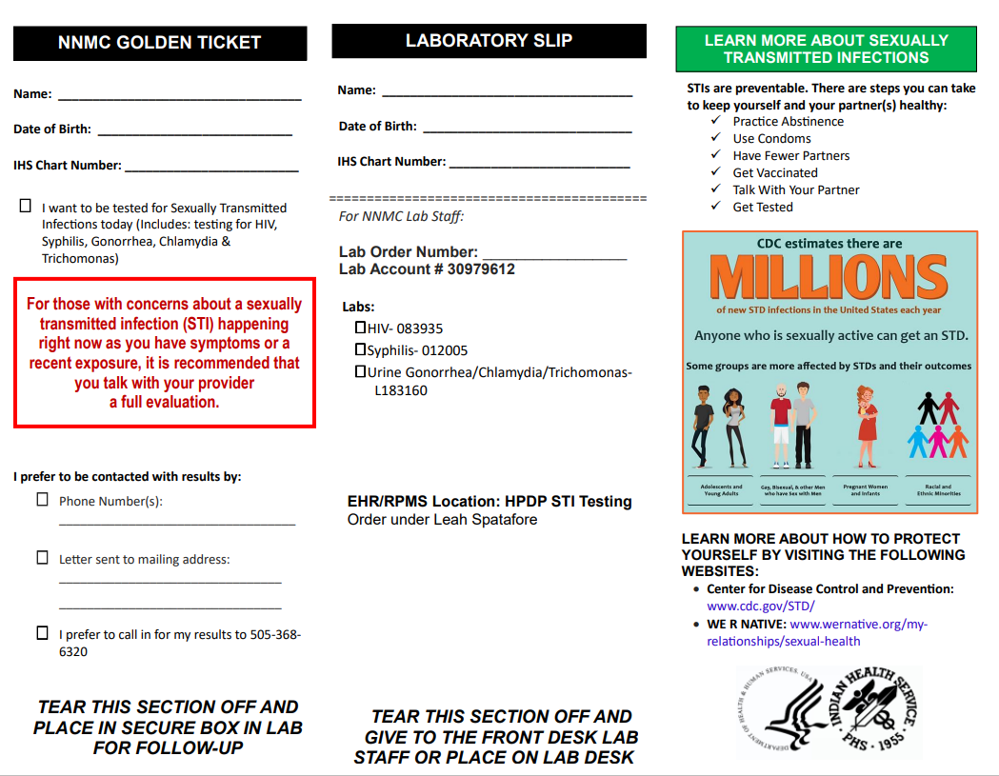

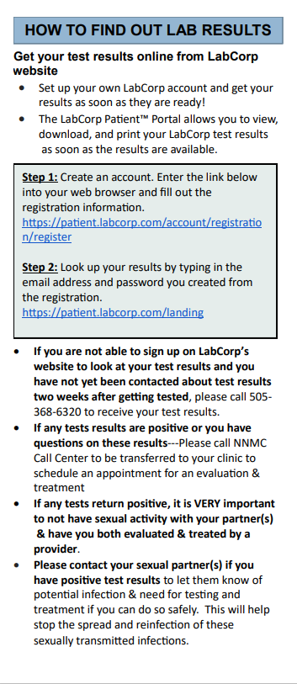
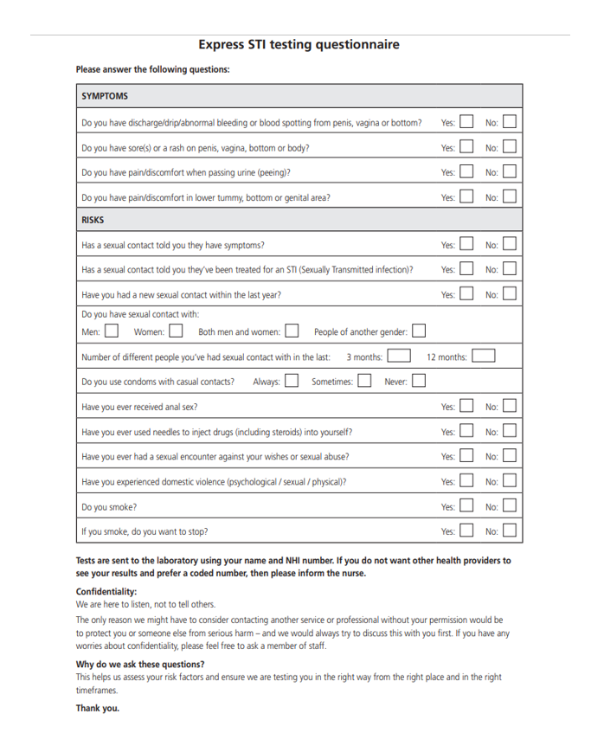PHARYNGEAL COLLECTION (for Chlamydia and Gonorrhea)

1. Specimens can be collected either by the clinician or the patient.
2. For patients opting to self-swab, instructions will be provided by the clinician.
3. Obtain supplies: Specimens are collected using the Gen-Probe APTIMA Combo2 Unisex Swab Collection Kit. Kits are stored at room temperature.
4. Use the small APTIMA testing swab, not the larger cleansing swab.
5. After opening the mouth, insert the swab and vigorously rub the tonsils and the posterior pharynx.
6. Carefully remove the swab, not touching any area of the mouth.
7. Insert the swab into the APTIMA transport tube and break off the swab at the score line.
8. Cap the tube tightly; label the tube with the patient’s name and date of collection.
9. Record the specimen source on the label.

RECTAL SWAB (for Chlamydia and Gonorrhea)

1. Specimens can be collected either by the clinician or the patient.
2. For patients opting to self-swab, instructions will be provided by the clinician.
3. Obtain supplies: Specimens are collected using the Gen-Probe APTIMA Combo2 Unisex Swab Collection Kit. Kits are stored at room temperature.
4. Use the small APTIMA testing swab, not the larger cleansing swab.
5. Insert the swab approximately 3 – 5 cm into the rectum and rotate against the rectal wall several times (at least 3 times).
6. Swabs that are grossly contaminated with feces should be discarded and the collection repeated.
7. Carefully remove the swab, and insert the swab into the APTIMA transport tube.
8. Break off the swab at the score line, and cap the tube tightly.
9. Label the tube with the patient’s name and date of collection.
10. Record the specimen source on the label.

VAGINAL SWAB (for Chlamydia and Gonorrhea)

1. Specimens can be collected either by the clinician or the patient.
2. For patients opting to self-swab, instructions will be provided by the clinician.
3. Obtain supplies: Specimens are collected using the Gen-Probe APTIMA Combo2 Unisex Swab Collection Kit. Kits are stored at room temperature.
4. Use the small APTIMA testing swab, not the larger cleansing swab.
5. Separate the labia and insert the swab into the vagina approximately 2 inches past the introitus.
6. Rotate the swab several times (at least 3 times) making sure the swab touches the walls of the vagina so that moisture is absorbed by the swab.
7. Carefully remove the swab, and insert the swab into the APTIMA transport tube.
8. Break off the swab at the score line, and cap the tube tightly.
9. Label the tube with the patient’s name and date of collection.
10. Record the specimen source on the label.
URINE (for Chlamydia and Gonorrhea)

- Preferably, the patient should not have urinated for at least one hour prior to specimen collection.
- Direct patient to provide a first-catch urine (approximately 20 to 30 mL of the initial urine stream) into a urine collection cup free of any preservatives.
- Collection of larger volumes of urine may result in specimen dilution that may reduce test sensitivity; lesser volumes may not adequately rinse organisms into the specimen.
- Female patients should not cleanse the labial area prior to providing the specimen.
- Add urine to the Aptima® Combo 2 urine collection device.
- The final volume must be between the two black lines on the device (about 2 mL).

PHLEBOTOMY

1. Nurses, phlebotomists, and technicians can perform venipuncture only after successful completion of required education and competency validation.
2. Routine venipuncture may be performed in the upper extremities. The usual sites for venipuncture in the antecubital area include the cephalic, basilic, median-cephalic, and median-basilic veins. EXCEPTION: Pediatric nurses may draw from the scalp and lower extremities.
3. For patient comfort and safety no more than two venipuncture attempts may be made by one practitioner. If two practitioners are unsuccessful, the ordering Physician/NP/PA is to be notified.
4. Reposition arm as tolerated to promote blood flow.
5. Perform venipuncture for phlebotomy on the opposite extremity of an infusion or a PICC line. If phlebotomy must be performed on the extremity with infusing solutions, a vein below or distal to the site of infusion should be used.
6. A vascular access device may be used for the purpose of drawing blood specimens with the exception of blood cultures on any patient requiring blood sampling only when venipuncture is not feasible.
7. Needles are never to be re-capped.
8. The labeling of ALL specimens MUST BE DONE at the collection site and in the presence of the patient after performing patient verification and obtaining the specimen.
9. Before all procedures, perform hand hygiene and don gloves.

Peripheral Blood Specimen Collection
EQUIPMENT:
- Clean gloves
- Latex-free single use tourniquet
- Alcohol Pad, 70% Isopropyl
- Blood collection safety needle or adapter with safety Butterfly needle
- Blood Collection holder and insert if needed
- Adhesive bandage or 2x2 gauze with tape
- Appropriate bar code labels and/or laboratory requisition
- Specimen collection bag

PROCEDURE:
1. Verify order.
2. Perform hand hygiene.
3. Verify patient according to standard Policy & Procedure
4. Don clean gloves.
5. Apply tourniquet and select appropriate vein by sight or palpation. When possible, have patient open and close fist “lightly”.

Note: Tourniquet application should not exceed one minute
6. Cleanse site with alcohol pad for 5 seconds using friction in a back and forth motion. Allow area to air dry.
7. Attach butterfly needle with luer adapter to blood collection holder.
8. Support patient’s extremity while patient is in supine/sitting position.
9. Remove cover of needle and stabilize selected vein.
10. Hold the needle with bevel in upright position at 30-degree angle or less and puncture skin and vein in one motion.
NOTE: When using a butterfly needle, observe for flashback in tubing.
a) If unsuccessful and needle is removed from the site, a new sterile needle is required for the second attempt.
b) If patient complains of a shooting electrical pain sensation, tingling or numbness remove the needle immediately.
11. Secure the blood collection holder in place and insert tubes into holder to puncture the stopper.
12. Remove filled bottles and invert gently to mix
13. If additional specimens are required, insert additional blood tubes, as
directed above.
14. Release the tourniquet when all specimens are collected.
15. Withdraw needle slowly while simultaneously placing a gauze pad over the
venipuncture site and apply gentle pressure.
16. Verify safety mechanism on the needle has been activated.
17. Using 2x2 gauze apply firm pressure at puncture site to minimize bleeding.
18. Apply adhesive bandage or 2x2 with tape over venipuncture site.
19. Dispose of needle and holder in sharps container.
20. Attach patient’s ID label to each blood specimen tube at the point of
collection in the presence of the patient.

REFERENCES:
Infusion Nursing Standards of Practice (2021). Journal of Intravenous Nursing, 44(1S) (Supplement to January/ February 2021).

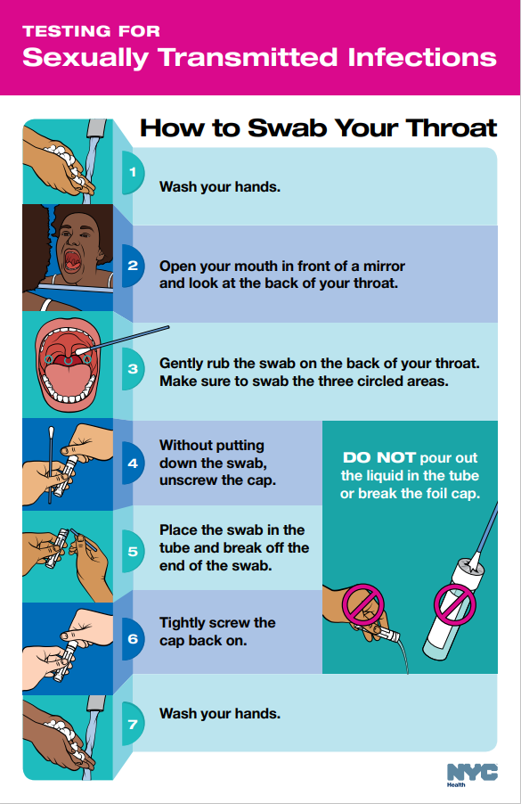
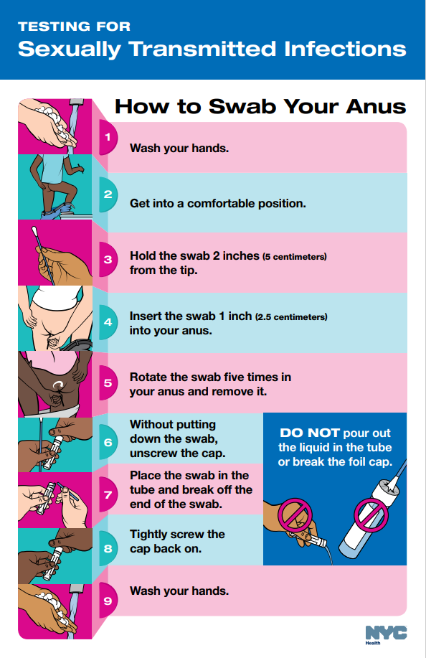
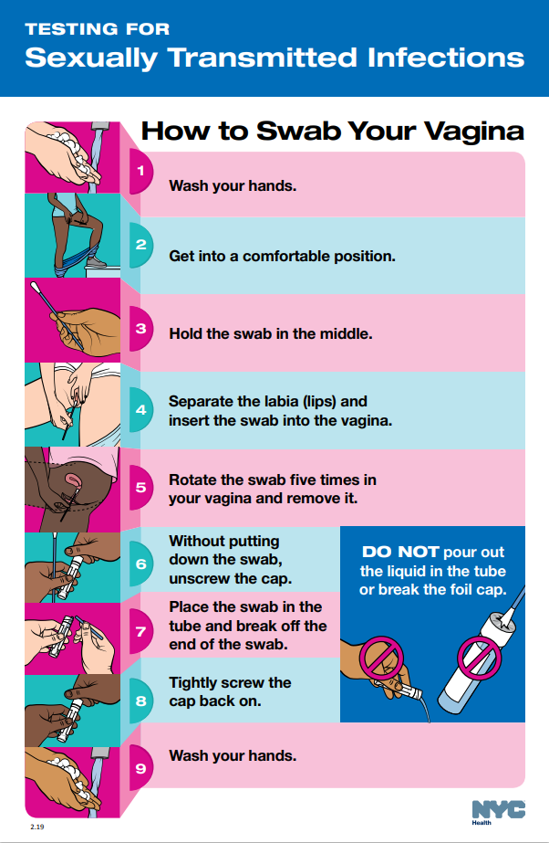

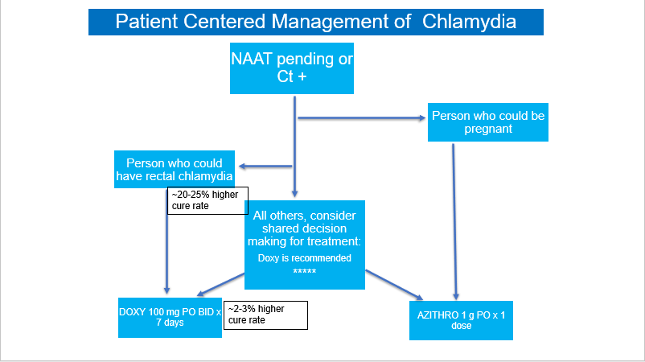

Administration of Penicillin G for Treatment of Syphilis

Indications, Dosage and Administration
Penicillin G, for the treatment of Treponema pallidum:
- Primary/Secondary/Early latent: 2.4 million units IM, once
- Late latent/Unknown duration: 2.4 million units IM, 3 doses, given 7 days apart
- In pregnant people, if subsequent doses are missed by greater than 9 days, must restart entire series
- In non-pregnant people, if subsequent doses are missed by greater than 10-14 days (case dependent), must restart entire series

- Identify space is available that ensures privacy for the patient.
- Administer Penicillin G 2.4 million units in divided doses of 1.2 million units by deep IM injection into each dorso or ventrogluteal site at the same visit.
- When administering in the dorsogluteal site, only inject in the upper outer quadrant of the buttock. Do not inject into or near an artery or nerve.
- Use a 21 gauge, thin-wall 1-1/2 inch needle for administration, adjusting accordingly based on patient’s muscle mass.
- Because of the high concentration of suspended material, the needle may be blocked if the injection is not made at a slow, steady rate.
- Following the injection, apply pressure until bleeding has ceased.
- Patient should wait 15 minutes before leaving the facility to monitor for immediate adverse reaction.
- If adverse reaction occurs while waiting in the facility, refer to anaphylaxis management protocol
- If symptoms occur after leaving the facility, instruct patients to seek emergency care immediately.

Contraindications
- Penicillin G is contraindicated in patients with known hypersensitivity to penicillin.
- However, fewer than 1% of the whole population are truly allergic to penicillin.
- Approximately 80% of patients with IgE-mediated penicillin allergy lose their sensitivity after 10 years.
- Correctly identifying those who are not truly penicillin-allergic can decrease unnecessary use of broad-spectrum antibiotics.
- Evaluate the patient for a true penicillin allergy (IgE-mediated) by conducting a history and physical, and when appropriate, a skin test and challenge dose.
- History and physical: What kinds of reaction occurred? How long ago did the reaction occur? How was the reaction managed? What was the outcome?
- Characteristics of an IgE-mediated (Type 1) reaction: Occur immediately or usually within one hour. Hives, angioedema, wheezing and shortness of breath, anaphylaxis.
- Anaphylaxis: Requires at least two of the following symptoms: Skin (hives, flushing, itching, angioedema), Respiratory (cough, nasal congestion, shortness of breath, chest tightness, wheezing, choking, change in voice quality), Cardiovascular (hypotension, syncope, tachy/bradycardia, tunnel vision, chest pain, sense of impending doom, loss of consciousness), Gastrointestinal (nausea, vomiting, cramping, diarrhea)
- Penicillin Skin Test
- Challenge Doses
- If penicillin allergy is ruled out, remove from allergy list on patient’s electronic health record
- Pregnant people with confirmed hypersensitivity to penicillin should be desensitized to receive penicillin.

Stability and Storage Recommendations
Penicillin G is stored at refrigerated temperatures, 2-8ºC, keep from freezing.
To help with injection related pain, Penicillin G can be taken out of the refrigerator and warmed to room temperature immediately before administration (do not use heat packs).

Side Effects
- May experience mild, temporary pain at the injection site.
- May experience diarrhea following treatment.
- Jarisch-Herxheimer reaction: fever, chills, headache, or fatigue
- A Jarisch-Herxheimer reaction is a set of temporary side effects that may occur within a few hours after treatment of early syphilis; although not everyone will have this reaction.
- Do not be alarmed, this is not an allergic response and usually ends in 24 hours.
- Take acetaminophen or ibuprofen as directed by your clinician, if needed to help relieve symptoms.
- This reaction rarely occurs after treatment of late syphilis.
- If any of these effects persist or worsen, instruct patient to contact their healthcare provider.

Protocol for Treatment of Anaphylaxis

- Early Recognition of Anaphylaxis
- Because anaphylaxis requires immediate treatment, diagnosis is primarily made based on recognition of clinical signs and symptoms. Signs and symptoms in adults and children include:
- Respiratory: sensation of throat closing or tightness, stridor (high-pitched sound while breathing), hoarseness, respiratory distress (such as shortness of breath or wheezing), coughing, trouble swallowing/drooling, nasal congestion, rhinorrhea, sneezing
- Gastrointestinal: nausea, vomiting, diarrhea, abdominal pain, or cramps
- Cardiovascular: dizziness; fainting; tachycardia (abnormally fast heart rate); hypotension (abnormally low blood pressure); pulse difficult to find or “weak”; cyanosis (bluish discoloration); pallor; flushing
- Skin/mucosal: generalized hives; widespread redness; itching; conjunctivitis; or swelling of eyes, lips, tongue, mouth, face, or extremities
- Neurologic: agitation; convulsions; acute change in mental status; sense of impending doom (a feeling that something bad is about to happen)
- Other: sudden increase in secretions (from eyes, nose, or mouth); urinary incontinence

- Anaphylaxis should be considered when signs or symptoms are generalized (i.e., if there are generalized hives or more than one body system is involved) or are serious or life-threatening in nature, even if they involve a single body system (e.g., hypotension, respiratory distress, or significant swelling of the tongue or lips).

- Symptoms of anaphylaxis often occur within 15-30 minutes of medication administration, though it can sometimes take several hours for symptoms to appear. Early signs of anaphylaxis can resemble a mild allergic reaction, and it is often difficult to predict whether initial, mild symptoms will progress to become an anaphylactic reaction. In addition, symptoms of anaphylaxis might be more difficult to recognize in people with communication difficulties, such as long-term care facility residents with cognitive impairment, those with neurologic disease, or those taking medications that can cause sedation. Not all symptoms listed above are necessarily present during anaphylaxis, and not all patients have skin reactions.

- If anaphylaxis is suspected, administer epinephrine as soon as possible, contact emergency medical services, and transfer patients to a higher level of medical care. In addition, instruct patients to seek immediate medical care if they develop signs or symptoms of an allergic reaction after their observation period ends and healthcare providers have left.

- Management of anaphylaxis in the field
If anaphylaxis is suspected, take the following steps:
- Rapidly assess airway, breathing, circulation, and mentation (mental activity).
- Call for emergency medical services (EMS).
- Place the patient in a supine position (face up), with feet elevated, unless upper airway obstruction is present, or the patient is vomiting.
- Epinephrine (1 mg/ml aqueous solution [1:1000 dilution]) is the first-line treatment for anaphylaxis and should be administered immediately.
- In adults, administer a 0.3 mg intramuscular dose using a premeasured or prefilled syringe, or an autoinjector, in the mid-outer thigh (through clothing if necessary).
- The maximum adult dose is 0.5 mg per dose.
- A dose of epinephrine may be repeated approximately every 5-15 minutes if symptoms do not improve or if they return while waiting for EMS. The number and timing of epinephrine doses should be recorded and communicated to EMS.
- Because of the acute, life-threatening nature of anaphylaxis, there are no contraindications to epinephrine administration.
- Antihistamines (e.g., H1 or H2 antihistamines) and bronchodilators do not treat airway obstruction or hypotension and, thus, are not first-line treatments for anaphylaxis. Although they can help provide relief for hives and itching (antihistamines) or symptoms of respiratory distress (bronchodilators), in a patient with anaphylaxis they should only be administered after epinephrine.
- Because anaphylaxis may recur after patients begin to recover, monitoring in a medical facility for at least four hours is advised, even after complete resolution of symptoms and signs.
- Considerations for anaphylaxis management in special populations (see below for Older Adults and Homebound People).

- Older Adults
There are no contraindications to the administration of epinephrine for the treatment of anaphylaxis. Although adverse cardiac events, such as myocardial infarction or acute coronary syndrome, have been reported in some patients who received epinephrine for treatment of anaphylaxis (particularly among older adults with hypertension and/or atherosclerotic heart disease), epinephrine is the first-line treatment for anaphylaxis. It is important that locations such as long-term care facilities, have staff members available who are able to recognize the signs and symptoms of anaphylaxis. This will help not only to ensure appropriate and prompt treatment for patients with anaphylaxis, but also to avoid unnecessary epinephrine administration to patients who do not have anaphylaxis.

- Homebound people requiring home services
Homebound people who might be at increased risk for anaphylaxis following anti-bacterial administration (i.e., people with those with a history of anaphylaxis due to any cause) should consider transport to a setting where medical care is immediately available in the event of anaphylaxis following administration. If home anti-bacterial administration is the only option for the identified patient, and through risk assessment, it is determined that the benefits of anti-bacterial administration at home outweigh the potential risk for anaphylaxis, healthcare providers (PHN, STI, CHR, MVO) should ensure they are able to manage anaphylaxis. This includes appropriate screening, post-administration observation, medications and supplies, staff qualifications for recognition and treatment of anaphylaxis, ability to call for EMS, and location in an area where EMS is available.

- Patient counseling
Patients who experience a severe allergic reaction (e.g., anaphylaxis) after a dose of anti-bacterial medication should be instructed not to receive additional doses of the same anti-bacterial medication.

- Documentation
Any severe allergic reaction should be promptly documented in the patient’s EHR for future reference.
Administration of Ceftriaxone for Treatment of Gonorrhea

Indications, Dosage and Administration
Ceftriaxone, for the treatment of Neisseria gonorrhea (cervical/urethral, pharyngeal and rectal):
- 500 mg IM, deep ventro/dorsogluteal
- Pain can be lessened when reconstituted with 0.9mL 1% lidocaine, based on manufacturer’s instructions (alternate diluent is sterile water)

Contraindications
Ceftriaxone is contraindicated in patients with known hypersensitivity to ceftriaxone sodium, any component of the container or other cephalosporins. Ceftriaxone is a 3rd generation cephalosporin therefore safe for use in penicillin allergic patients.
Lidocaine is contraindicated if client is sensitive or allergic to lidocaine or has a history of a reaction to local aesthetics.

Reconstitution Table
Vial Size | Volume Added to Vial | Approximate Available Volume | Approximate Average Concentration
0.5 g | 0.9 mL | 1.0 mL | 0.5 g/mL
Shake well until dissolved.

Stability and Storage Recommendations
Ceftriaxone powder is stored at room temperature, 15-30ºC. Solutions should be reconstituted immediately before use. If storage is required, these solutions should be refrigerated and used within 48 hours from time of reconstitution.

Reconstitution
- Dilute single dose vials of ceftriaxone with 0.9 mL 1% lidocaine solution (or sterile water) using a 1 mL syringe. Total volume will be approximately 1 mL.
- Discard syringe and needle used for drawing up lidocaine/sterile water.
- Shake vial well until all powder is dissolved.
- Draw up the diluted product in a 2 mL syringe.
- Discard the needle used to draw up the medication and attach 1.5 inch 21-gauge needle to syringe.
Dorso or ventrogluteal muscle is recommended for administration. Following the injection, apply pressure until bleeding has ceased but do not massage the area. Patient should wait 15 minutes before leaving the facility to ensure no immediate adverse reaction.

REFERENCES:
Anti-infective Review Panel. Anti-infective Guidelines for Community-acquired Infections. Toronto:MUMS Guideline Clearinghouse; 2013 page viii

