HPV Social Media Toolkit
Post 1: (Can be used alone or with Posts 2, 3, & 4)
The Human Papilloma Virus (HPV) is the most commonly transmitted virus in the world and can lead to 6 types of cancer (throat/mouth, anal, penile, vaginal, vulva, and cervix.) Thankfully there is a vaccine to protect everyone starting at age 9. Talk to your doctor to make sure you and your children are protected.

You can find more vaccination resources at Native Boost website at www.npaihb.org/native-boost #nativeboost #vaccination #cancerprevention

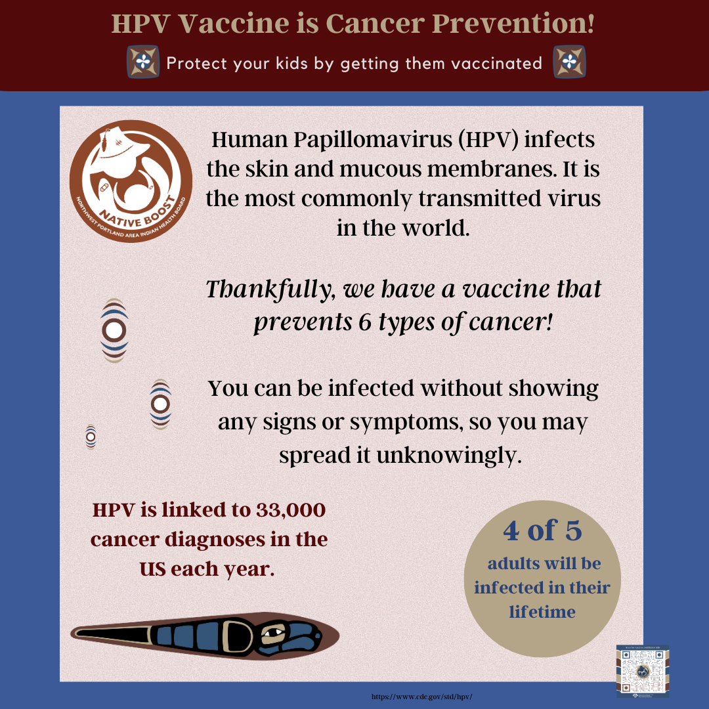

Post 2: (Can be used alone or with Posts 1, 3, & 4)
The HPV vaccine prevents cancer! The Human Papilloma Virus (HPV) is the most commonly transmitted virus in the world and can lead to 6 types of cancer (throat/mouth, anal, penile, vaginal, vulva, and cervix.) Thankfully there is a vaccine to protect everyone starting at age 9. Talk to your doctor to make sure you and your children are protected.

You can find more vaccination resources at Native Boost website at www.npaihb.org/native-boost #nativeboost #vaccination #cancerprevention

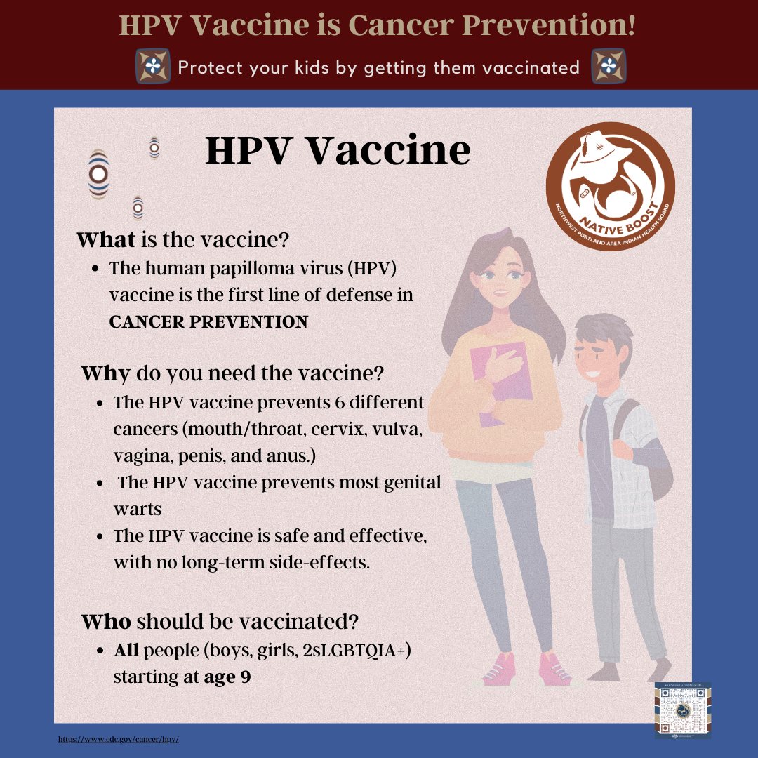

Post 3: (Can be used alone or with Posts 1,2, & 4)
The Human Papilloma Virus (HPV) is the most commonly transmitted virus in the world and can lead to 6 types of cancer (throat/mouth, anal, penile, vaginal, vulva, and cervix.) Thankfully there is a vaccine to protect everyone starting at age 9.

The prime age to begin the vaccine series is between ages 9-12 for both boys and girls. If you miss that time-frame, it’s ok! Starting later will still protect your child.

Talk to your doctor to make sure your children are protected.

You can find more vaccination resources at Native Boost website at www.npaihb.org/native-boost #nativeboost #vaccination #cancerprevention

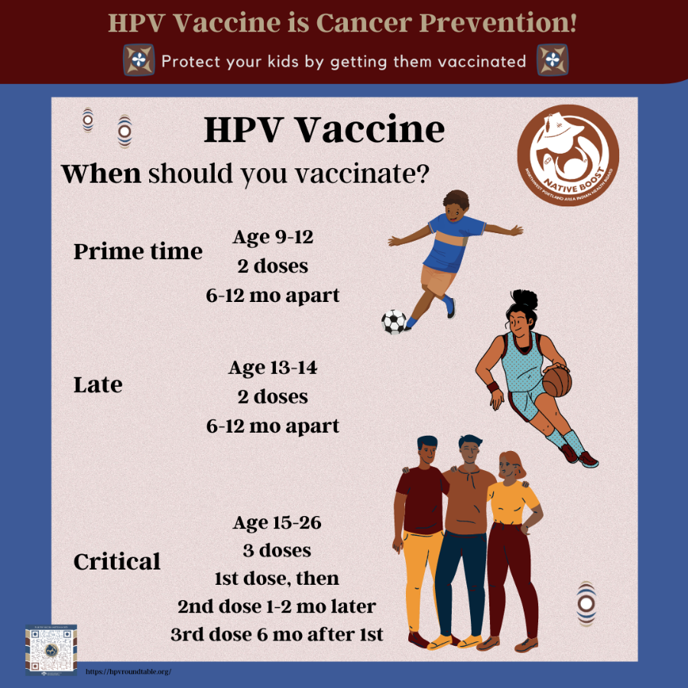

Post 4: (Can be used alone or with Posts 1, 2, & 3)
HPV can cause 6 types of cancer (mouth/throat, penis, anus, vagina, vulva, cervix), but thankfully, there is a vaccine!

As with any vaccine, there may be mild side effects. The cancer protection you receive from the HPV vaccine far outweighs any possible side effects.

You can find more vaccination resources at Native Boost website at www.npaihb.org/native-boost #nativeboost #vaccination #cancerprevention

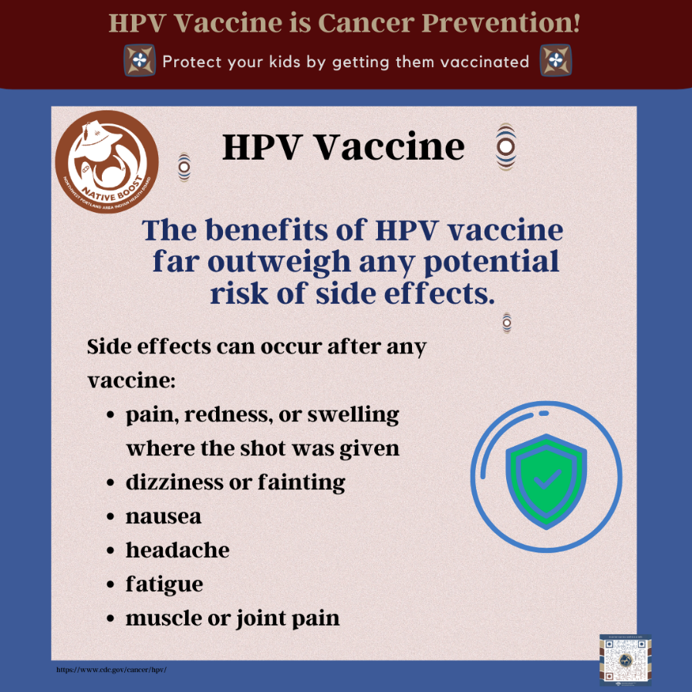

Post 5:
HPV can infect the mouth, throat, and cause cancers of the oropharynx (back of the throat, base of the tongue, and tonsils). This is called oropharyngeal cancer. HPV is thought to cause 70% of oropharyngeal cancers in the United States.

Anyone can get the human papillomavirus (HPV) which can cause six types of cancers, including oropharyngeal cancer.

How can you protect yourself from the HPV infection?

Get the HPV vaccine!

You can find more vaccination resources at Native Boost website at www.npaihb.org/native-boost #nativeboost #vaccination #cancerprevention

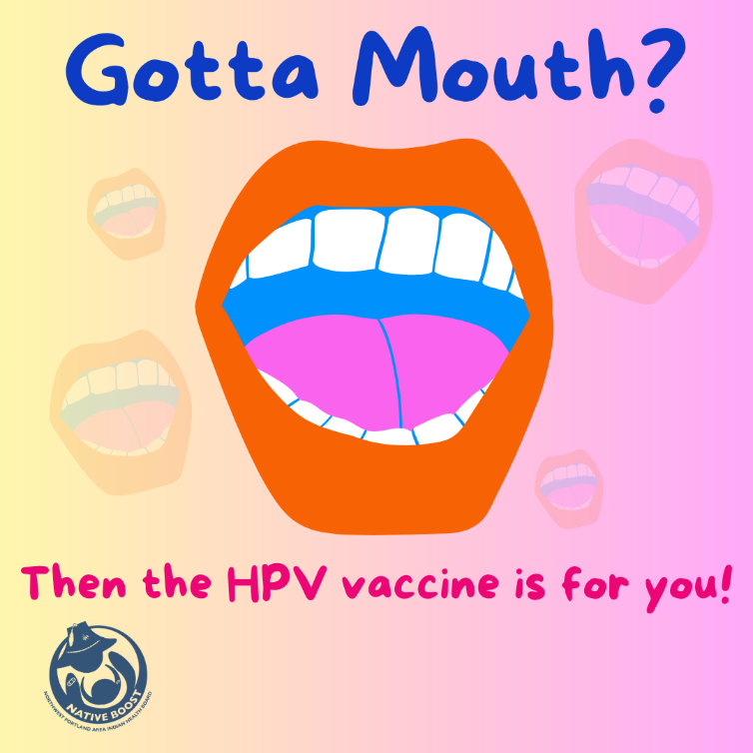

Post 6:
HPV can infect the mouth, throat, and cause cancers of the oropharynx (back of the throat, base of the tongue, and tonsils). This is called oropharyngeal cancer. HPV is thought to cause 70% of oropharyngeal cancers in the United States.

Anyone can get the human papillomavirus (HPV) which can cause six types of cancers, including oropharyngeal cancer.

How can you protect yourself from the HPV infection?

Get the HPV vaccine!

You can find more vaccination resources at Native Boost website at www.npaihb.org/native-boost #nativeboost #vaccination #cancerprevention

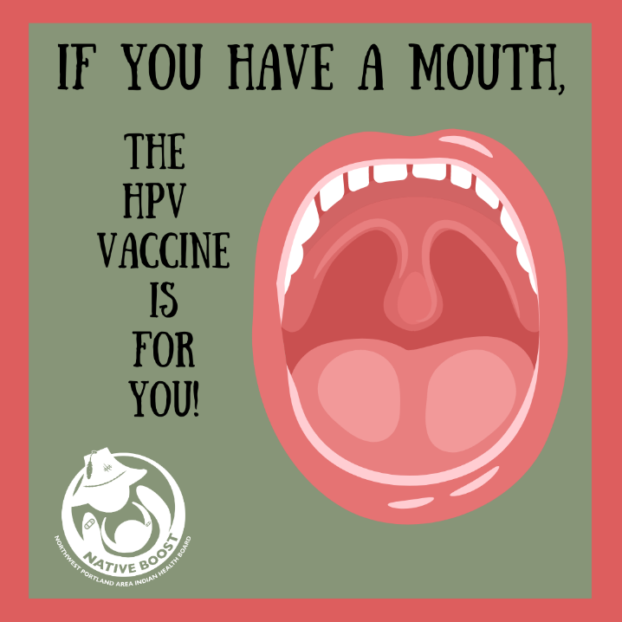

Post 7:
HPV can infect the mouth, throat, and cause cancers of the oropharynx (back of the throat, base of the tongue, and tonsils). This is called oropharyngeal cancer. HPV is thought to cause 70% of oropharyngeal cancers in the United States.

Anyone can get the human papillomavirus (HPV) which can cause six types of cancers, including oropharyngeal cancer.

How can you protect yourself from the HPV infection?

Get the HPV vaccine!

You can find more vaccination resources at Native Boost website at www.npaihb.org/native-boost #nativeboost #vaccination #cancerprevention

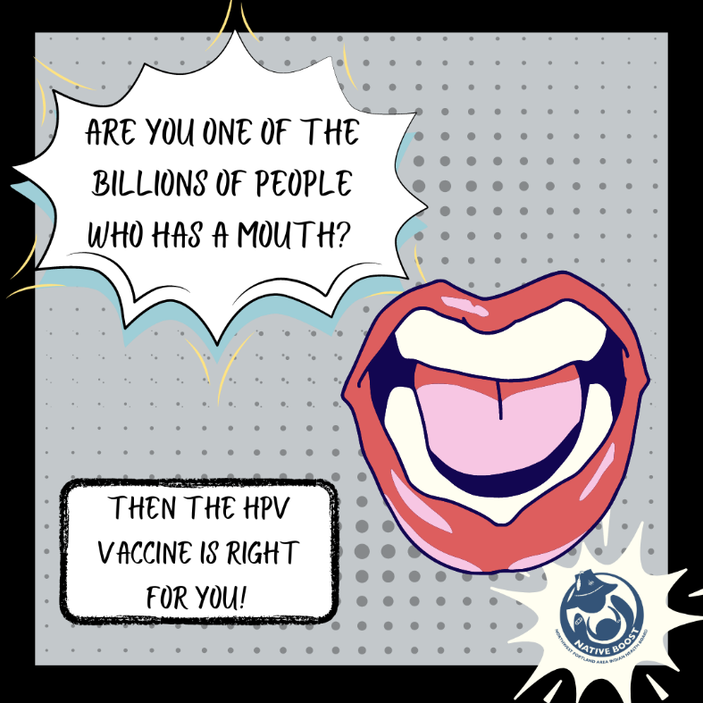

Post 8:
HPV can infect the mouth, throat, and cause cancers of the oropharynx (back of the throat, base of the tongue, and tonsils). This is called oropharyngeal cancer. HPV is thought to cause 70% of oropharyngeal cancers in the United States.

Anyone can get the human papillomavirus (HPV) which can cause six types of cancers, including oropharyngeal cancer.

How can you protect yourself from the HPV infection?

Get the HPV vaccine!

You can find more vaccination resources at Native Boost website at www.npaihb.org/native-boost #nativeboost #vaccination #cancerprevention

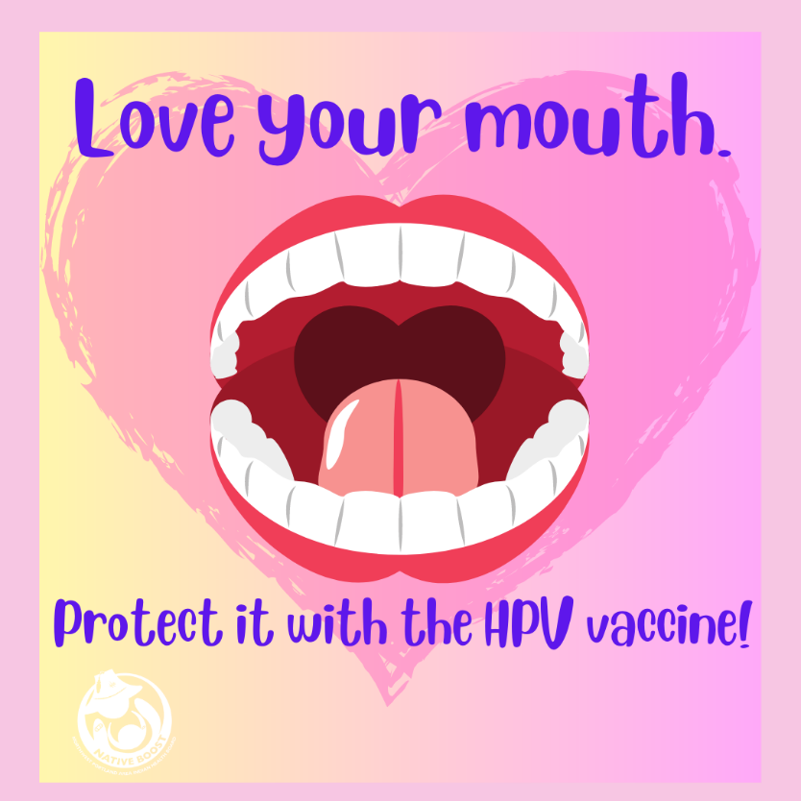

Post 9:
The Human Papilloma Virus (HPV) is the most commonly transmitted virus in the world and can lead to 6 types of cancer (throat/mouth, anal, penile, vaginal, vulva, and cervix.) Thankfully there is a vaccine to protect everyone starting at age 9.

The prime age to begin the vaccine series is between ages 9-12 for both boys and girls. If you miss that time-frame, it’s ok! Starting later will still protect your child.

Talk to your doctor to make sure you and your children are protected.

You can find more vaccination resources at Native Boost website at www.npaihb.org/native-boost #nativeboost #vaccination #cancerprevention

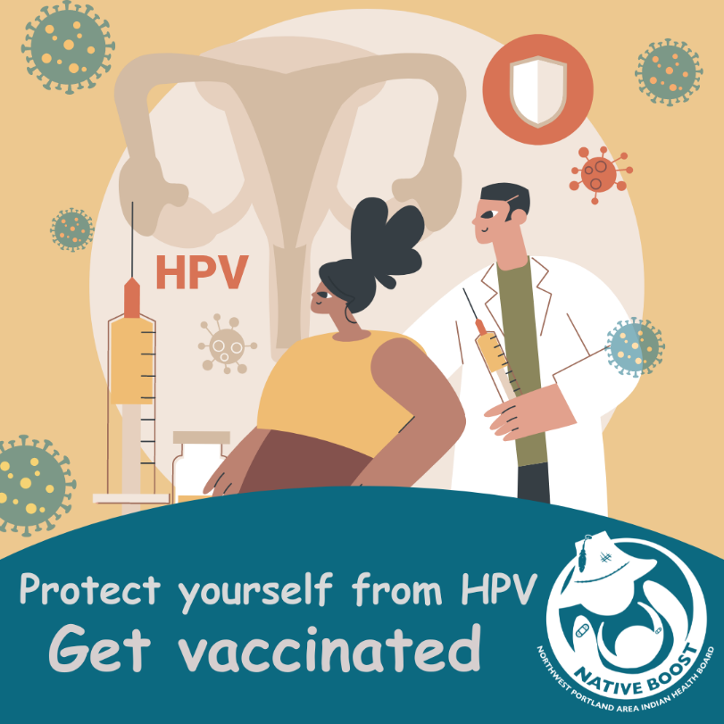

Post 10:
Think the HPV vaccine is just for girls? Think again! The Human Papilloma Virus (HPV) is the most commonly transmitted virus in the world and can lead to 6 types of cancer (throat/mouth, anal, penile, vaginal, vulva, and cervix.) Thankfully there is a vaccine to protect everyone starting at age 9.

The prime age to begin the vaccine series is between ages 9-12 for both boys and girls. If you miss that time-frame, it’s ok! Starting later will still protect your child.

Talk to your doctor to make sure you and your children are protected.

You can find more vaccination resources at Native Boost website at www.npaihb.org/native-boost #nativeboost #vaccination #cancerprevention

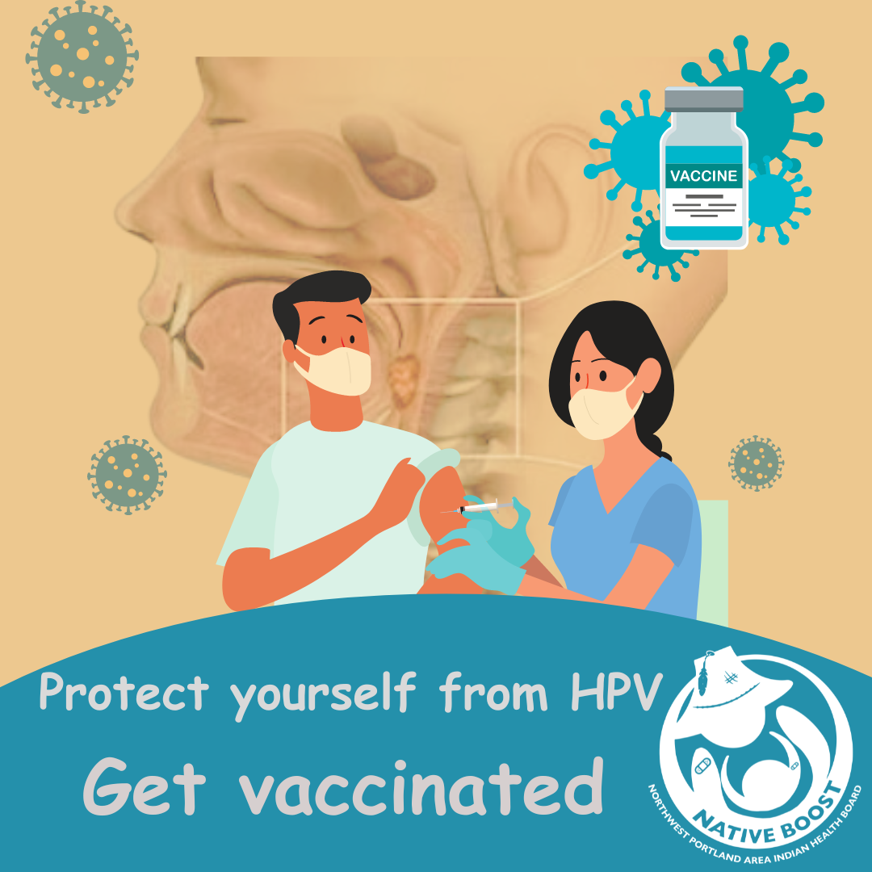

Post 11:
Confused about HPV and the HPV vaccine? Don’t worry! We got you!
The Human Papilloma Virus (HPV) is the most commonly transmitted virus in the world and can lead to 6 types of cancer (throat/mouth, anal, penile, vaginal, vulva, and cervix.) Thankfully there is a vaccine to protect everyone starting at age 9.

The prime age to begin the vaccine series is between ages 9-12 for both boys and girls. If you miss that time-frame, it’s ok! Starting later will still protect your child.

Talk to your doctor to make sure you and your children are protected.

You can find more vaccination resources at Native Boost website at www.npaihb.org/native-boost #nativeboost #vaccination #cancerprevention

